**Software Requirement Specification (SRS)**

Of

**Placement module**

For Implementation of

**Campus Management Software**

at

**World Skill Center (WSC)**

**Sustainable Outreach And Universal**

**Leadership (SOUL) Limited**

A. Abstract 3

B. Introduction 3

C. Definition, Acronyms and Abbreviations 3

D. Overview of the Document 3

E. Scope of Training and Placement Module 4

F. WSC Training and Placement Process Flow 4

G. List of Screens and their Descriptions 8

H. Placement 9

Placement Company 9

Placement Drive 11

Placement Drive Application 14

Placement Blocked Student 16

Placement Tool 18

Selection Round 19

Selection Round Report 21

Internship Drive 22

Internship Application 24

Internship Participant Selection 26

Internship Final List Declaration 27

Internship Completion Status 28

TnP Program 29

TnP Event 30

Participant Registration 32

Participant Attendance 33

Event Feedback 35

Generate Certificate Tool 36

Generate Certificate 37

Entrepreneurship 38

Sector 40

Resume 41

# Abstract

Software Requirements Gathering is one of the first phases of system development. This phase results in the Software Requirements Specification (SRS) document, which must contain a complete, concise, high-quality description of the system being considered.

# Introduction

The World Skill Center (WSC) is a premier advanced skill training institute established by the Government of Odisha, Skill Development and Technical Education Department, through the Odisha Skill Development Authority (OSDA). The WSC will impart advanced skill training in eight trades from engineering and service sectors. WSC caters primarily to induct the best talent from ITIs and Polytechnics and train them to become globally employable in emerging areas such as "Industry 4.0". WSC is housed in a state-of-the-art, 18-storey, air-conditioned building with nearly half a million square feet of space in the heart of capital city of Bhubaneswar.

With the Implementation of campus management software for WSC the goal is to streamline the operations and functions of the campus by integrating various processes, such as admissions, course registration, academic progress tracking, and financial management, HRMS, Procurement and Inventory management, etc into a unified system. The implementation also aims at providing a user-friendly interface for all stakeholders, making it easier for them to access the necessary information and complete their tasks with ease. The modules to be covered during the implementation of the software includes:

|  |  |
| --- | --- |
| Students Management Modules | Infrastructure Management |
| Academic System | Finance and Accounting System |
| Procurement & Inventory Management | Training and Placement |
| Human Resources Management System | Application Integration |

# Definition, Acronyms and Abbreviations

The following table explains the terms and abbreviations used in the document:

|  |  |
| --- | --- |
| **Abbreviation** | **Description** |
| SRS | Software Requirements Specification |
| SLCM | Student Life Cycle Management |
| R | Rename - When a field is Renamed |
| N | New - When a New field is Added |
| D | Delete - When an Existing field is Deleted |
| NA | Not Applicable |
| TnP | Training and Placement |

# Overview of the Document

This requirement document provides a detailed overview of the functional requirements of a project. It serves as a communication tool between stakeholders, including developers, project managers, and end-users. The purpose of this requirement document is to define and document the project's objectives, scope, and expectations, and to ensure that all stakeholders have a clear understanding of what the project entails.

This document covers all the functional requirements of the Training module of the ERP product. THis module helps in organizing the entire training setup such as Participants Database, Application forms, Participant attendance etc.

# Scope of Training and Placement Module

* Placement
* Internships
* Seminars and Conferences
* Candidate Selection
* Round scheduling
* Result declaration
* Drive creation
* Certificate generation
* Event creation and scheduling

Following functionalities are covered in this SRS document:

* **Placement company record creation**
* **Placement drive creation**
* **Internship drive creation**
* **Program and event creation**
* **Program and event scheduling**
* **Student shortlisting**
* **Student application**
* **Round Scheduling**
* **Result declaration**
* **Certification generation**
* **Resume creation**

# WSC Training and Placement Process Flow

1. **Seminars and Conferences Process flow and description**

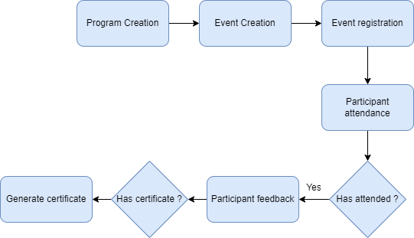

Fig : 1 Seminar and conference Process Flow

**Program Creation**

This allows the user to create and maintain records of a TnP Program which is composed of different TnP Events in the system.

**Event creation**

This allows the user to create and maintain records of a TnP event which can be put in a program in the system.

**Event registration**

This allows the user to create and maintain records of registration forms for an event.

**Participant attendance**

This allows the user to record attendance of participants during an event and maintain the record in the system

**Participant feedback**

This allows the user to collect and maintain the records of the feedback submitted by the participants of an event in the system.

**Generate certificate**

This allows the user to generate certificates for the participants who have attended the event.

1. **Placement process flow and description**

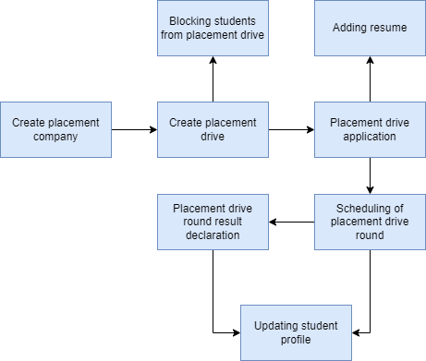

Fig : 2 Placement Process Flow

**Create placement company**

This allows the user to create and maintain records of companies who are interested in offering jobs to the WSC students.

**Create placement drive**

This allows the user to create and maintain records of placement drives for different companies.

**Blocking students from placement drives**

This blocks students who have been deemed to be ineligible for a drive based on the organizations discretion.

**Placement drive application**

This allows the students to apply for a drive that they are eligible for.

**Adding Resume**

This allows the students to create resumes in the system which they will attach to their applications to different placement drives.

**Scheduling of placement drive round**

This allows the user to schedule a round of a placement drive for all the eligible applicants.

**Placement drive round result declaration**

This allows the user to declare the result of a round of a placement drive upon the completion of the round.

**Updating student profile**

The profile of a student will be update with the result of rounds for different placement drives that the student applied for.

1. **Internship process flow and description**

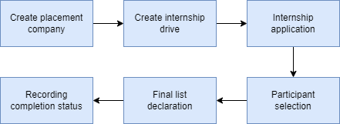

Fig : 3 Internship Process Flow

**Create placement company**

This allows the user to create and maintain records of companies who are interested in offering jobs to the WSC students.

**Create internship drive**

This allows the user to create and maintain records of internship drives for different companies.

**Internship application**

This allows the students to apply for an internship drive that they are eligible for.

**Participant selection**

This allows the training and placement department to select participants from the pool of applications

**Final list declaration**

This allows the training and placement department to publish the final list of participants for an internship drive.

**Recording completion status**

This allows the training and placement department to record the completion status of an internship drives participants.

# List of Screens and their Descriptions

The following tables lists the pages used in Training and Placement module :

|  |  |  |
| --- | --- | --- |
| **Sl no** | **Screen Name** | **Description** |
|  | Placement Company | This allows the user to create and maintain the record of organizations offering placement and internship opportunities to the WSC students. |
|  | Placement Drive | This allows the user to create and modify placement drive records for different companies that are offering placement opportunities to the WSC students. |
|  | Placement Drive Application | This allows a WSC student to apply for a placement drive that they are eligible for. |
|  | Placement Blocked Student | This screen allows the user to block students from placement drives. |
|  | Placement Tool | This allows the user to schedule different rounds in a placement drive and declare the rounds results. |
|  | Selection Round | This screen keeps the records of individual applications status for a round in a placement drive. |
|  | Selection Round Report | This screen is to be used by the WSC students to view a report regarding their performance in the different rounds of a placement drive. |
|  | Internship Drive | This allows the user to create and modify internship drive for different companies that are offering internship opportunities to the WSC students. |
|  | Internship Application | This allows a WSC student to apply to an internship drive. |
|  | Internship Participant Selection | This allows the user to select participants for an internship drive from the pool of submitted applications. |
|  | Internship Final List Declaration | This screen allows the user to publish the final list of participants chosen for a particular internship drive. |
|  | Internship Completion Status | This allows the user to mark and record the completion status of a participant regarding an internship drive. |
|  | TnP Program | This screen allows the user to create and maintain records of programs that will be conducted by the WSC Training and Placement department. |
|  | TnP Event | This screen allows the user to create and maintain records of events that that will be conducted by the WSC Training and Placement department. |
|  | Participant Registration | This screen allows the user to register for events conducted by the Training and Placement department. |
|  | Participant Attendance | This allows the user to mark and keep track of the attendance of participants in an event. |
|  | Event Feedback | This allows a participant to submit feedback for a Training and Placement Event that they attended. |
|  | Generate Certificate Tool | This screen allows the user to generate certificates for the participants of an event. |
|  | Generate Certificate | This screen allows the user to generate certificates for individual students who participated in an event. |
|  | Entrepreneurship | This screen allows the user to create and manage records of companies formed by students or alumni of WSC. |
|  | Sector | This screen is to be used by the user to create and maintain records of industrial sectors that different companies work in. |
|  | Resume | This screen allows the user to create and maintain resumes. |

# Placement

Following are the screens used to achieve the functionalities of Placement

### Placement Company

**General Description**

The following table describes overall information about this screen:

|  |  |  |
| --- | --- | --- |
| **Description** | | This screen is used to record the details of a company who has shown interest in offering placements to WSC students. |
| **Navigation** | Home > Training and Placement > Masters > Placement Company | |
| **Pre-requisites** | NA | |
| **Existing Screen Name** | No Change | |
| **New Screen Name** | Placement Company | |

**Screenshot**

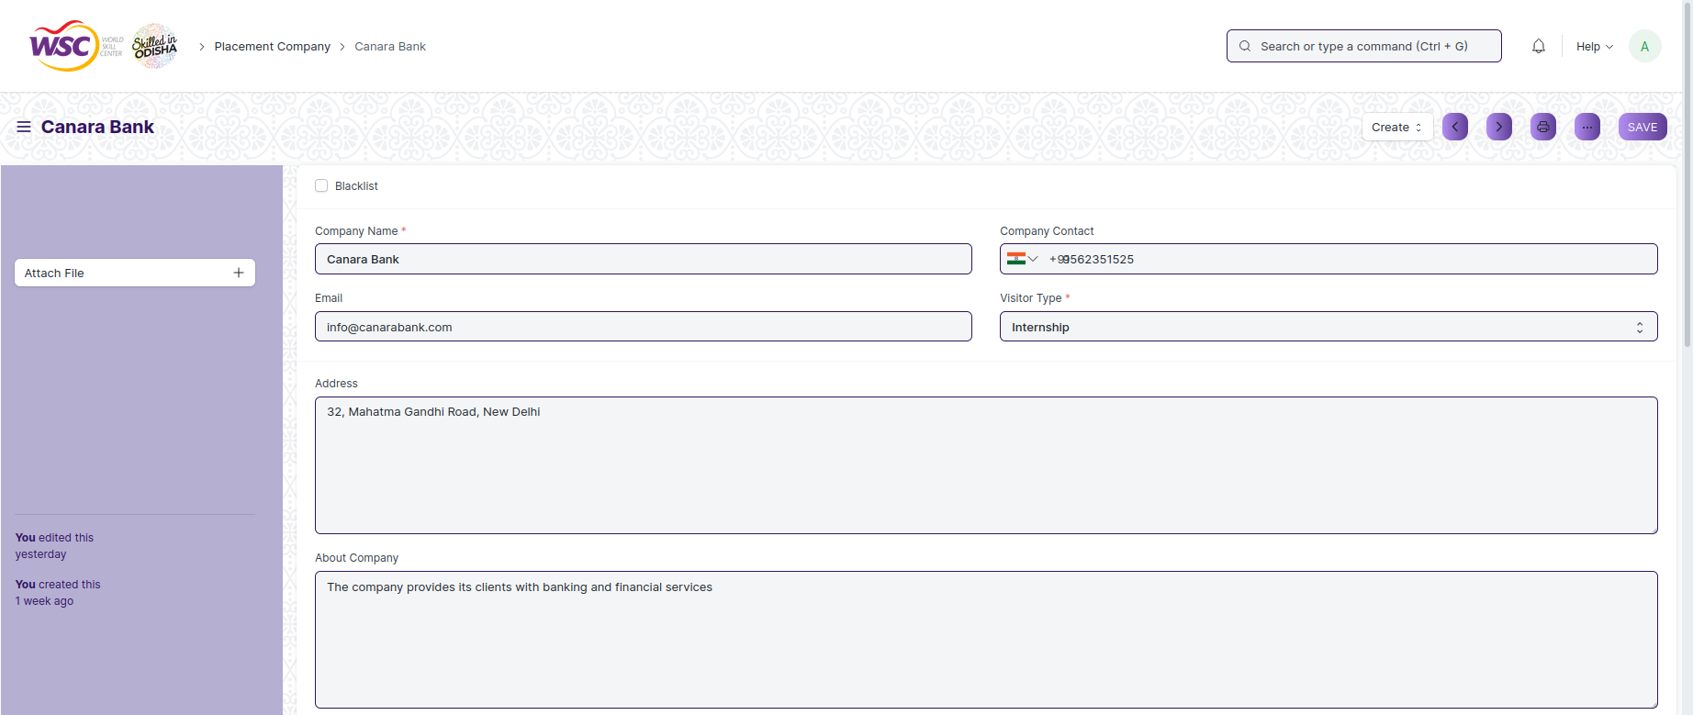

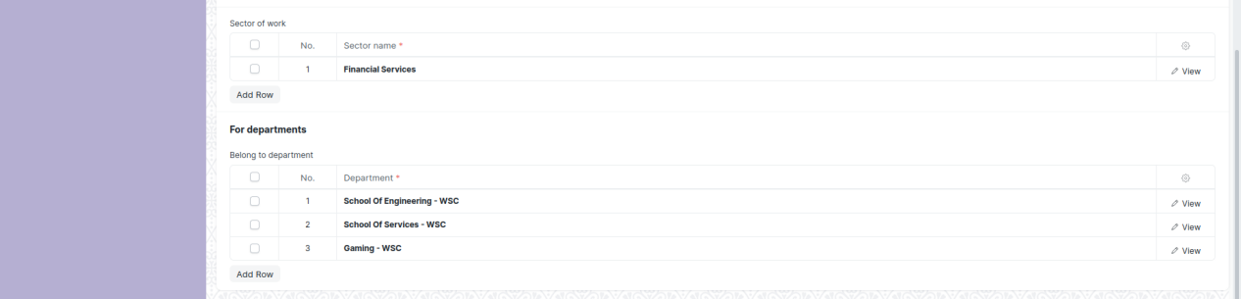

Fig 4: Placement Company Screen

**Field List**

The following table describes the UI fields present in this screen :

|  |  |  |  |  |  |  |
| --- | --- | --- | --- | --- | --- | --- |
| **ID** | **Field Name** | **Field Type** | **Mandatory** | **Validation/ Action** | **Remarks** | **R/N/D** |
| 1 | Blacklist | Checkbox |  |  |  |  |
| 2 | Company Name | Data | Yes |  |  |  |
| 3 | Email | Data |  | Email |  |  |
| 4 | Company Contact | Phone |  |  |  |  |
| 5 | Visitor Type | Select | Yes | Internship  Day 0 visitor  Day 1 visitor  Day 2 visitor  One time visitor  Normal visitor |  |  |
| 6 | Address | Small Text |  |  |  |  |
| 7 | About Company | Small Text |  |  |  |  |
| **Sector of Work** | | | | | | |
| 8 | Sector Name | Link | Yes | Sector |  |  |
| **Belong to department** | | | | | | |
| 9 | Department | Link | Yes | Department |  |  |

**User: Roles & Permission**

The following table describes the users and their roles and permissions for the screens :

|  |  |  |  |  |  |  |  |  |
| --- | --- | --- | --- | --- | --- | --- | --- | --- |
| **ID** | **Role** | **Read** | **Write** | **Create** | **Delete** | **Submit** | **Cancel** | **Amend** |
| 1 | Training and Placement Administrator | Yes | Yes | Yes | NA | NA | NA | NA |
| 2 | Student | Yes | No | No | NA | NA | NA | NA |

### Placement Drive

**General Description**

The following table describes overall information about this screen:

|  |  |  |
| --- | --- | --- |
| **Description** | | This screen allows the user to create and maintain records of placement drives created for different companies that are offering placements to the WSC students. |
| **Navigation** | Home > Training and Placement > Placement > Placement Drive | |
| **Pre-requisites** | NA | |
| **Existing Screen Name** | No Change | |
| **New Screen Name** | Placement Drive | |

**Screenshot**

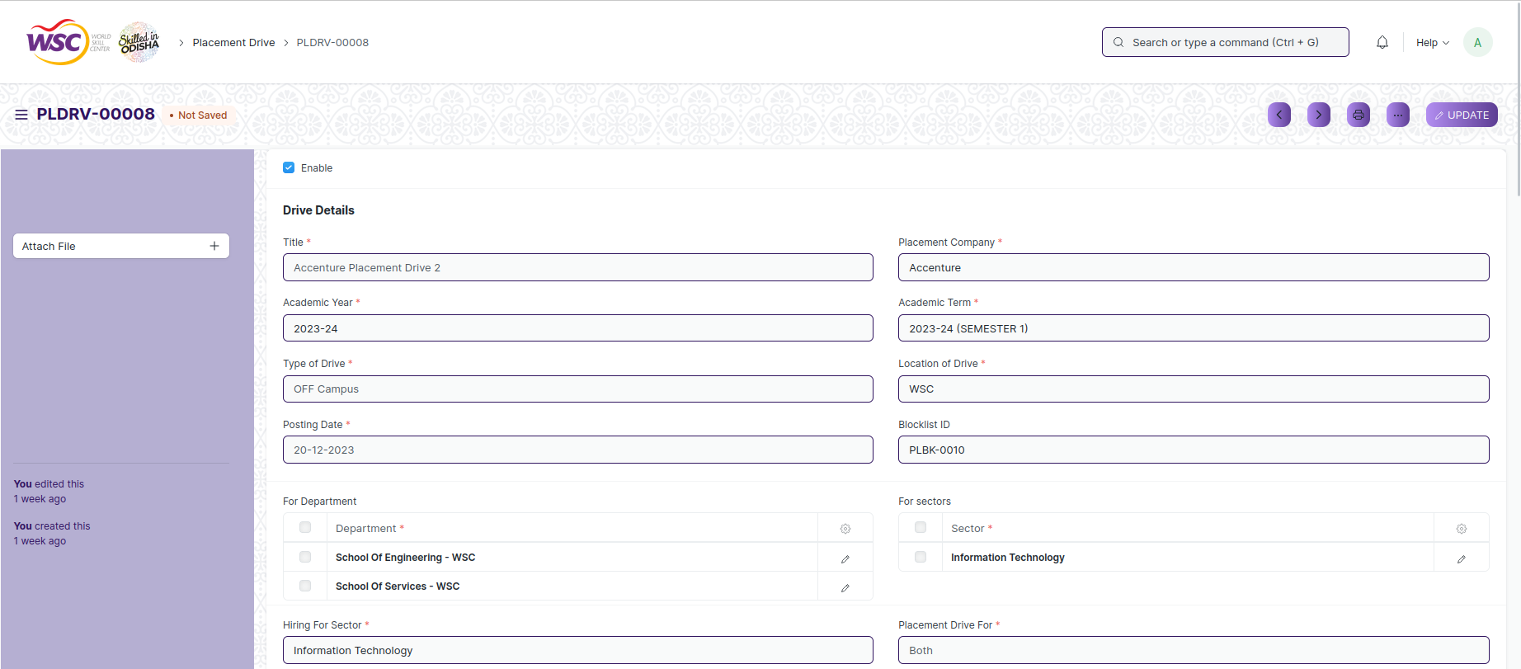

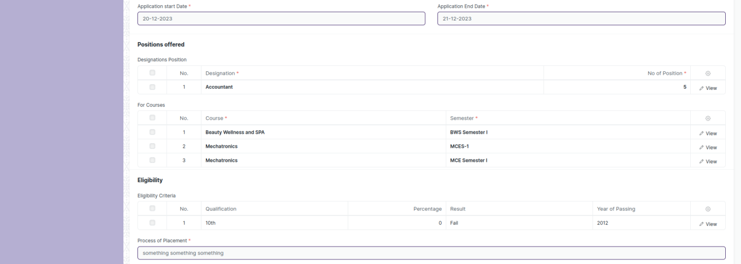

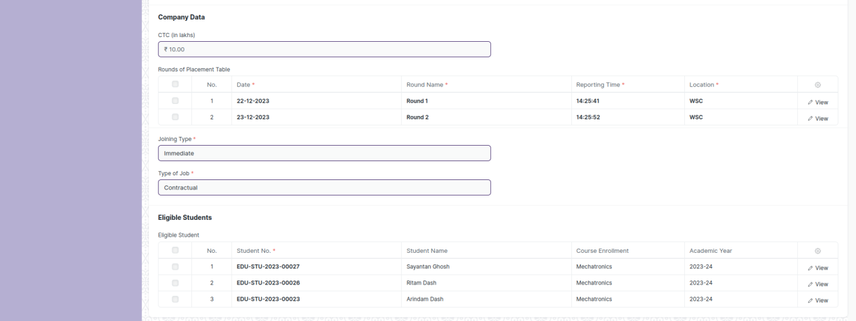

Fig 5: Placement Drive Screen

**Field List**

The following table describes the UI fields present in this screen :

|  |  |  |  |  |  |  |
| --- | --- | --- | --- | --- | --- | --- |
| **ID** | **Field Name** | **Field Type** | **Mandatory** | **Validation/ Action** | **Remarks** | **R/N/D** |
| 1 | Enable | Checkbox |  |  |  |  |
| 2 | Title | Data | Yes |  |  |  |
| 3 | Academic Year | Link | Yes | Academic Year |  |  |
| 4 | Type of Drive | Select | Yes | IN Campus  OFF Campus |  |  |
| 5 | Posting Date | Date | Yes |  |  |  |
| 6 | Placement Company | Link | Yes | Placement Company |  |  |
| 7 | Academic Term | Link | Yes | Academic Term |  |  |
| 8 | Location of Drive | Link | Yes | Location |  |  |
| 9 | Blocklist ID | Link |  | Placement Blocked Student |  |  |
| 10 | Current CGPA | Float |  |  |  |  |
| 11 | Active Backlog | Select |  | 0  1  2  3 |  |  |
| 12 | Hiring For Sector | Link | Yes | Sector |  |  |
| 13 | Application Start Date | Date | Yes |  |  |  |
| 14 | Placement Drive For | Select | Yes | Freshers  Experience  Both |  |  |
| 15 | Application End Date | Date | Yes |  |  |  |
| 16 | Process of Placement | Small Text | Yes |  |  |  |
| 17 | CTC(in lakhs) | Currency |  |  |  |  |
| 18 | Joining Type | Link | Yes | Joining Type |  |  |
| 19 | Type of Job | Link | Yes | Job Type |  |  |
| 20 | Tentative Joining Date | Date |  |  |  |  |
| 21 | Get Students | Button |  |  |  |  |
| 22 | Current Date | Date |  |  |  |  |
| **For Department** | | | | | | |
| 25 | Department | Link | Yes | Department |  |  |
| **For sectors** | | | | | | |
| 26 | Sector | Link | Yes | Sector |  |  |
| **Designations Position** | | | | | | |
| 27 | Designation | Link | Yes | Designation |  |  |
| 28 | No of Position | Int | Yes |  |  |  |
| **For Course** | | | | | | |
| 29 | Programs | Link | Yes | Programs |  |  |
| 30 | Semester | Link | Yes | Program |  |  |
| **Eligibility Criteria** | | | | | | |
| 31 | Qualification | Select |  | 10th  12th  Diploma  ITI  UG  PG |  |  |
| 32 | Percentage | Float |  |  |  |  |
| 33 | Result | Select |  | Pass  Fail |  |  |
| 34 | Year of Passing | Link |  | Year |  |  |
| **Rounds of Placement Table** | | | | | | |
| 35 | Date | Date |  |  |  |  |
| 36 | Round Name | Data |  |  |  |  |
| 37 | Reporting Time | Time |  |  |  |  |
| 38 | Location | Link |  |  |  |  |
| 39 | Contact Person Name | Data |  |  |  |  |
| 40 | Contact Person Number | Phone |  |  |  |  |
| 41 | Round Status | Data |  |  |  |  |
| **Eligible Student** | | | | | | |
| 42 | Student No. | Link | Yes | Student |  |  |
| 43 | Student Name | Data |  |  |  |  |
| 44 | Program Enrollment | Data |  |  |  |  |
| 45 | Academic Year | Data |  |  |  |  |

**User: Roles & Permission**

The following table describes the users and their roles and permissions for the screens :

|  |  |  |  |  |  |  |  |  |
| --- | --- | --- | --- | --- | --- | --- | --- | --- |
| **ID** | **Role** | **Read** | **Write** | **Create** | **Delete** | **Submit** | **Cancel** | **Amend** |
| 1 | Training and Placement Administrator | Yes | Yes | Yes | NA | Yes | Yes | Yes |
| 2 | Student | Yes | NA | NA | NA | NA | NA | NA |

### Placement Drive Application

**General Description**

The following table describes overall information about this screen:

|  |  |  |
| --- | --- | --- |
| **Description** | | This screen is used to record the details of an application submitted by a student for a placement drive. |
| **Navigation** | Home > Training and Placement > Placement > Placement Drive Application | |
| **Pre-requisites** | NA | |
| **Existing Screen Name** | No Change | |
| **New Screen Name** | Placement Drive Application | |

**Screenshot**

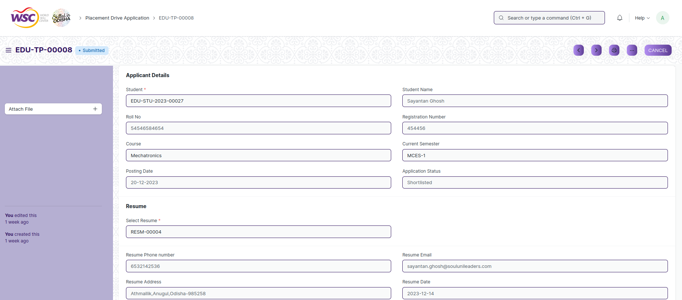

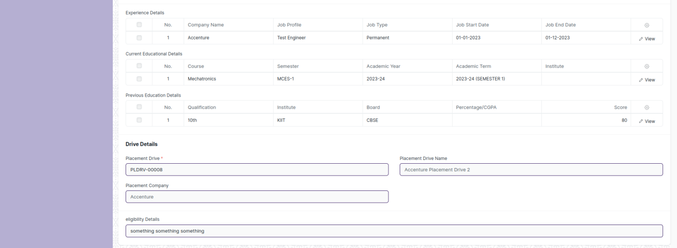

Fig 6: Placement Drive Application Screen

**Field List**

The following table describes the UI fields present in this screen :

|  |  |  |  |  |  |  |
| --- | --- | --- | --- | --- | --- | --- |
| **ID** | **Field Name** | **Field Type** | **Mandatory** | **Validation/ Action** | **Remarks** | **R/N/D** |
| 1 | Student | Link | Yes | Student |  |  |
| 2 | Roll No | Data |  |  |  |  |
| 3 | Programs | Link |  | Programs |  |  |
| 4 | Posting Date | Date |  |  |  |  |
| 5 | Student Name | Data |  |  |  |  |
| 6 | Registration Number | Data |  |  |  |  |
| 7 | Current Semester | Link |  | Program |  |  |
| 8 | Application Status | Select |  | Applied  Rejected  Shortlisted  Hired |  |  |
| 9 | Select Resume | Link | Yes | Resume |  |  |
| 10 | Resume Description | Small Text |  |  |  |  |
| 11 | Interests | Small Text |  |  |  |  |
| 12 | Resume Phone Number | Data |  |  |  |  |
| 13 | Resume Address | Data |  |  |  |  |
| 14 | Resume Place | Data |  |  |  |  |
| 15 | Resume Email | Data |  |  |  |  |
| 16 | Resume Place | Data |  |  |  |  |
| 17 | Resume Image | Data |  |  |  |  |
| 18 | Resume Signature | Data |  |  |  |  |
| 19 | Block Student | Checkbox |  |  |  |  |
| 20 | Placement Drive | Link | Yes | Placement Drive |  |  |
| 21 | Placement Company | Data |  |  |  |  |
| 22 | Eligibility Details | Text Editor |  |  |  |  |
| **Experience Details** | | | | | | |
| 23 | Company Name | Data |  |  |  |  |
| 24 | Job Profile | Data |  |  |  |  |
| 25 | Job Type | Select |  | Permanent  Internship  Contractual  Non-contractual |  |  |
| 26 | Job Start Date | Date |  |  |  |  |
| 27 | Job End Date | Date |  |  |  |  |
| 28 | Job Location | Data |  |  |  |  |
| 29 | Work Description | Small Text |  |  |  |  |
| **Current Educational Details** | | | | | | |
| 30 | Programs | Data |  |  |  |  |
| 31 | Semester | Data |  |  |  |  |
| 32 | Academic Year | Data |  |  |  |  |
| 33 | Academic Term | Data |  |  |  |  |
| 34 | Institute | Data |  |  |  |  |
| 35 | Location | Data |  |  |  |  |
| **Previous Education Details** | | | | | | |
| 36 | Qualification | Link |  | Eligibility Parameters |  |  |
| 37 | Institute | Data |  |  |  |  |
| 38 | Board | Data |  |  |  |  |
| 39 | Percentage/CGPA | Data |  |  |  |  |
| 40 | Score | Data |  |  |  |  |
| 41 | Year of Completion | Data |  |  |  |  |
| **Technical Skills** | | | | | | |
| 42 | Skill | Data |  |  |  |  |
| Non Technical Skills | | | | | | |
| 43 | Skill | Data |  |  |  |  |
| **Languages** | | | | | | |
| 44 | Language | Data |  |  |  |  |

**User: Roles & Permission**

The following table describes the users and their roles and permissions for the screens :

|  |  |  |  |  |  |  |  |  |
| --- | --- | --- | --- | --- | --- | --- | --- | --- |
| **ID** | **Role** | **Read** | **Write** | **Create** | **Delete** | **Submit** | **Cancel** | **Amend** |
| 1 | Training and Placement Administrator | Yes | Yes | Yes | NA | Yes | Yes | Yes |
| 2 | Student | Yes | Yes | Yes | NA | Yes | Yes | Yes |

### Placement Blocked Student

**General Description**

The following table describes overall information about this screen:

|  |  |  |
| --- | --- | --- |
| **Description** | | This screen is used to block students from a placement drive. |
| **Navigation** | Home > Training and Placement > Placement > Placement Blocked Student | |
| **Pre-requisites** | NA | |
| **Existing Screen Name** | No Change | |
| **New Screen Name** | Placement Blocked Student | |

**Screenshot**

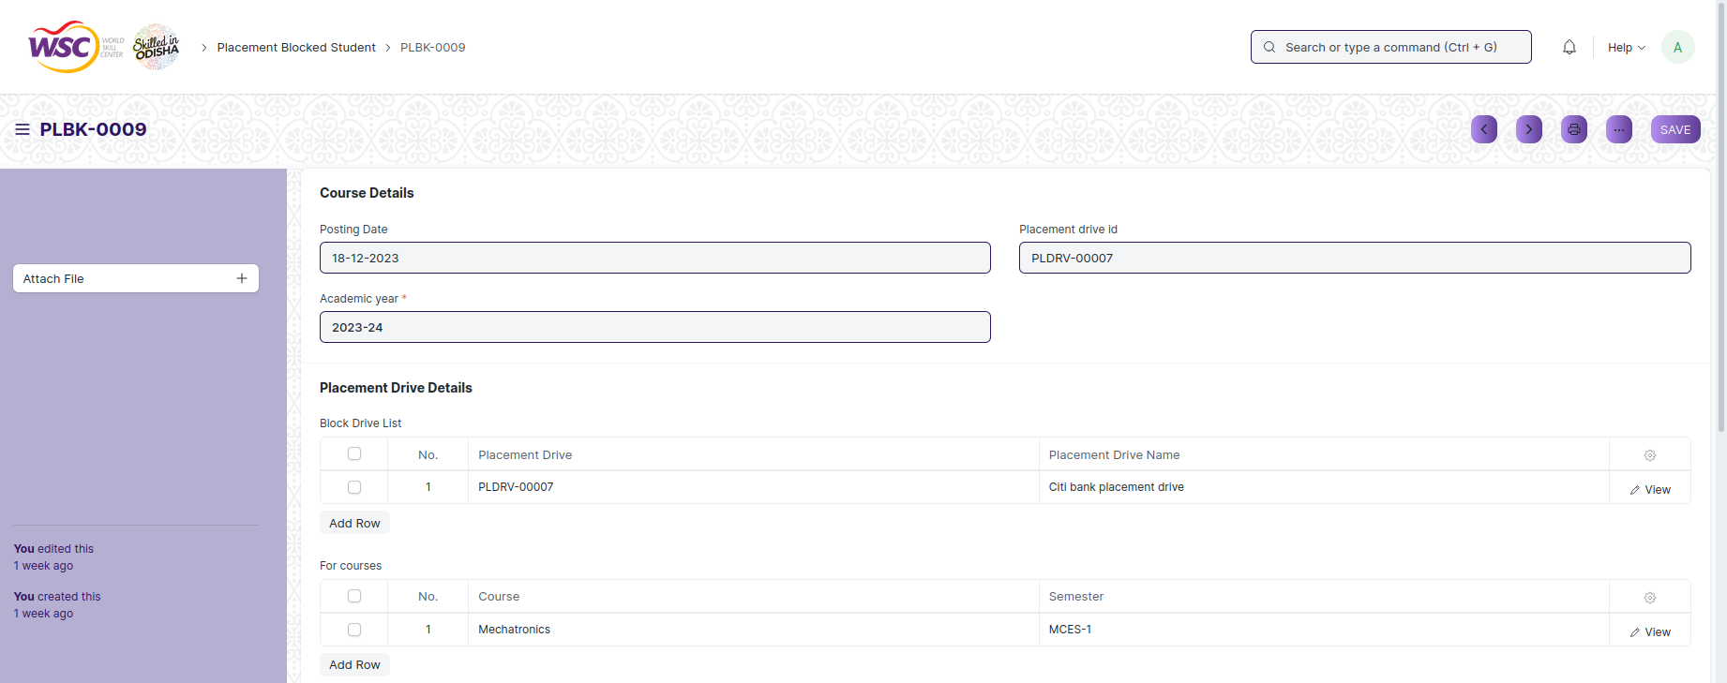



Fig 7: Placement Blocked Student Screen

**Field List**

The following table describes the UI fields present in this screen :

|  |  |  |  |  |  |  |
| --- | --- | --- | --- | --- | --- | --- |
| **ID** | **Field Name** | **Field Type** | **Mandatory** | **Validation/ Action** | **Remarks** | **R/N/D** |
| 1 | Posting Date | Date |  |  |  |  |
| 2 | Academic Year | Link | Yes |  |  |  |
| 3 | Placement Drive ID | Data |  |  |  |  |
| **Block Drive List** | | | | | | |
| 4 | Placement Drive |  |  |  |  |  |
| 5 | Placement Drive Name |  |  |  |  |  |
| **For Courses** | | | | | | |
| 6 | Programs | Link |  | Programs |  |  |
| 7 | Semester | Link |  | Program |  |  |
| **Blocked Student** | | | | | | |
| 8 | Student | Link |  | Student |  |  |
| 9 | Student Name | Data |  |  |  |  |
| 10 | Reason | Data |  |  |  |  |

**User: Roles & Permission**

The following table describes the users and their roles and permissions for the screens :

|  |  |  |  |  |  |  |  |  |
| --- | --- | --- | --- | --- | --- | --- | --- | --- |
| **ID** | **Role** | **Read** | **Write** | **Create** | **Delete** | **Submit** | **Cancel** | **Amend** |
| 1 | Training and Placement Administrator | Yes | Yes | Yes | NA | NA | NA | NA |

### Placement Tool

**General Description**

The following table describes overall information about this screen:

|  |  |  |
| --- | --- | --- |
| **Description** | | This tool is used for the scheduling and result declaration of different rounds of a placement drive. |
| **Navigation** | Home > Training and Placement > Placement > Placement Tool | |
| **Pre-requisites** | NA | |
| **Existing Screen Name** | No Change | |
| **New Screen Name** | Placement Tool | |

**Screenshot**

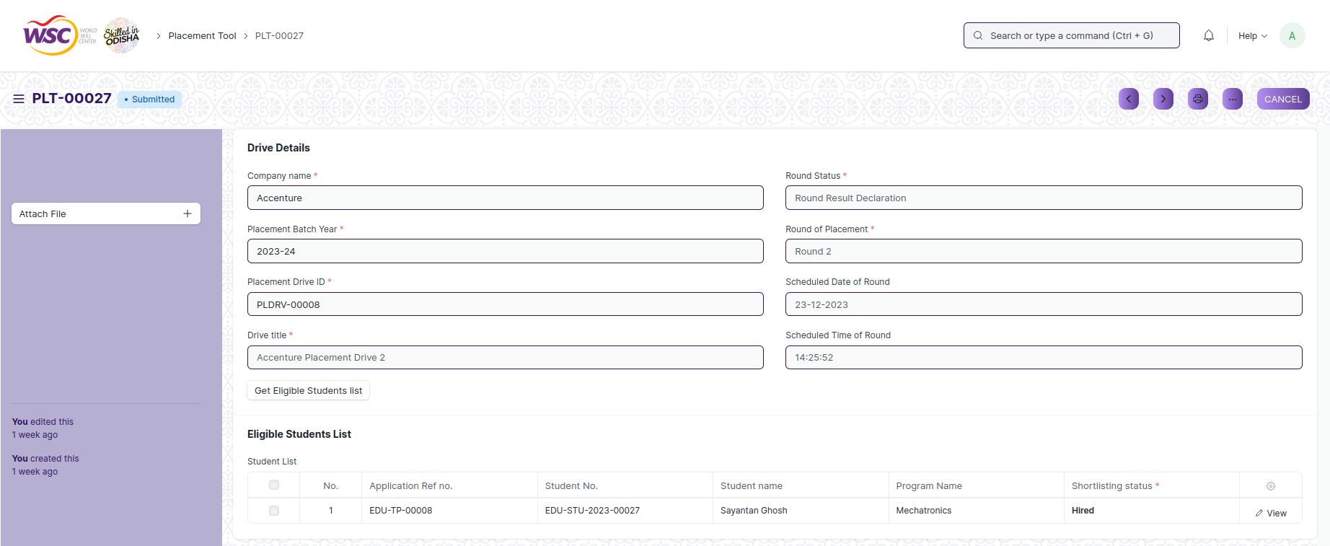

Fig 8: Placement Tool Screen

**Field List**

The following table describes the UI fields present in this screen :

|  |  |  |  |  |  |  |
| --- | --- | --- | --- | --- | --- | --- |
| **ID** | **Field Name** | **Field Type** | **Mandatory** | **Validation/ Action** | **Remarks** | **R/N/D** |
| 1 | Company Name | Link | Yes | Placement Company |  |  |
| 2 | Placement Batch Year | Link | Yes | Academic Year |  |  |
| 3 | Placement Drive ID | Link | Yes | Placement Drive |  |  |
| 4 | Drive title | Data | Yes |  |  |  |
| 5 | Get Eligible Students list | Button |  |  |  |  |
| 6 | Round Status | Select | Yes | Scheduling Of Round  Round Result Declaration |  |  |
| 7 | Round of Placement | Select | Yes |  |  |  |
| 8 | Scheduled Date of Round | Date |  |  |  |  |
| 9 | Scheduled Time of Round | Data |  |  |  |  |
| **Student List** | | | | | | |
| 10 | Application Ref no. | Link |  | Placement Drive Application |  |  |
| 11 | Student No. | Link |  | Student |  |  |
| 12 | Student Name | Data |  |  |  |  |
| 13 | Program Name | Data |  |  |  |  |
| 14 | Academic Year | Link |  | Academic Year |  |  |
| 15 | Semesters | Data |  |  |  |  |
| 16 | Shortlisting status | Select | Yes | Rejected  Shortlisted  Hired |  |  |
| 17 | Selection Round | Data |  |  |  |  |
| 18 | Last Round | Data |  |  |  |  |
| 19 | current application status | Data |  |  |  |  |

**User: Roles & Permission**

The following table describes the users and their roles and permissions for the screens :

|  |  |  |  |  |  |  |  |  |
| --- | --- | --- | --- | --- | --- | --- | --- | --- |
| **ID** | **Role** | **Read** | **Write** | **Create** | **Delete** | **Submit** | **Cancel** | **Amend** |
| 1 | Training and Placement Administrator | Yes | Yes | Yes | NA | Yes | Yes | Yes |

### Selection Round

**General Description**

The following table describes overall information about this screen:

|  |  |  |
| --- | --- | --- |
| **Description** | | This screen is used to manually enter records of students for placement drives. |
| **Navigation** | Home > Training and Placement > Placement > Selection Round | |
| **Pre-requisites** | NA | |
| **Existing Screen Name** | No Change | |
| **New Screen Name** | Selection Round | |

**Screenshot**

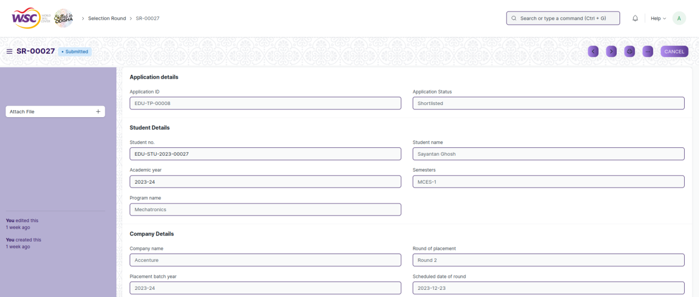



Fig 9: Selection Round Screen

**Field List**

The following table describes the UI fields present in this screen :

|  |  |  |  |  |  |  |
| --- | --- | --- | --- | --- | --- | --- |
| **ID** | **Field Name** | **Field Type** | **Mandatory** | **Validation/ Action** | **Remarks** | **R/N/D** |
| 1 | Student no. | Link |  | Student |  |  |
| 2 | Academic Year | Link |  | Academic Year |  |  |
| 3 | Program name | Data |  |  |  |  |
| 4 | Student name | Data |  |  |  |  |
| 5 | Semesters | Data |  |  |  |  |
| 6 | Company name | Data |  |  |  |  |
| 7 | Placement batch year | Data |  |  |  |  |
| 8 | Drive title | Data |  |  |  |  |
| 9 | Placement drive name | Data |  |  |  |  |
| 10 | Round of placement | Data |  |  |  |  |
| 11 | Scheduled date of round | Data |  |  |  |  |
| 12 | Shortlisting status | Data |  |  |  |  |
| 13 | Round Status | Data |  |  |  |  |
| 14 | Application Status | Data |  |  |  |  |
| 15 | Application ID | Data |  |  |  |  |
| 16 | Drive Round Status | Data | Yes |  |  |  |

**User: Roles & Permission**

The following table describes the users and their roles and permissions for the screens :

|  |  |  |  |  |  |  |  |  |
| --- | --- | --- | --- | --- | --- | --- | --- | --- |
| **ID** | **Role** | **Read** | **Write** | **Create** | **Delete** | **Submit** | **Cancel** | **Amend** |
| 1 | Training and Placement Administrator | Yes | Yes | Yes | NA | Yes | Yes | Yes |

### Selection Round Report

**General Description**

The following table describes overall information about this screen:

|  |  |  |
| --- | --- | --- |
| **Description** | | This screen is used to view the placement round results of students. |
| **Navigation** | Home > Academics > Placement & Drives > Selection Round | |
| **Pre-requisites** | NA | |
| **Existing Screen Name** | No Change | |
| **New Screen Name** | Selection Round | |

**Screenshot**

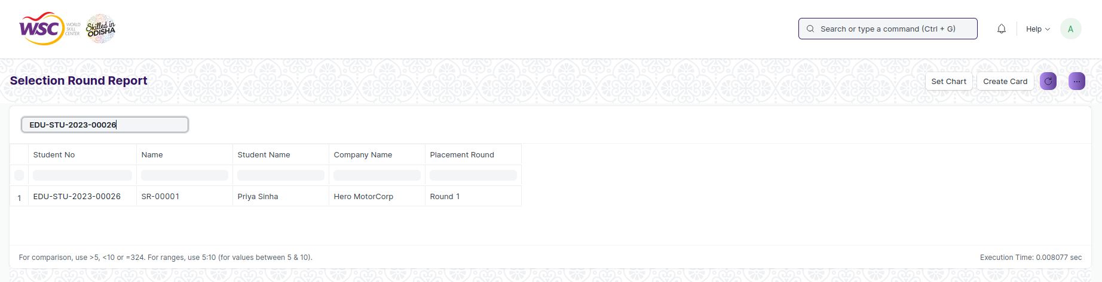

Fig 10 : Selection Round Report

**Field List**

The following table describes the UI fields present in this screen :

|  |  |  |  |  |  |  |
| --- | --- | --- | --- | --- | --- | --- |
| **ID** | **Field Name** | **Field Type** | **Mandatory** | **Validation/ Action** | **Remarks** | **R/N/D** |
| 1 | Student ID | Link |  | Student |  |  |

**Actions**

User will enter the search fields such as : From date and To date. Based on these inputs, the report will be shown.

**Report Fields**

|  |  |  |
| --- | --- | --- |
| **ID** | **Column Name** | **Description** |
|  | Student No | It shows the student ID number |
|  | Name | It shows the ID of the Selection Round record |
|  | Student Name | It shows the name of the student |
|  | Company Name | It shows the name of the company |
|  | Placement Round | It shows the name of the round |

**User: Roles & Permission**

The following table describes the users and their roles and permissions for the screens :

|  |  |  |  |  |  |  |  |  |
| --- | --- | --- | --- | --- | --- | --- | --- | --- |
| **ID** | **Role** | **Read** | **Write** | **Create** | **Delete** | **Submit** | **Cancel** | **Amend** |
| 1 | Training and Placement Administrator | Yes | NA | NA | NA | NA | NA | NA |
| 2 | Student | Yes | NA | NA | NA | NA | No | NA |

### Internship Drive

**General Description**

The following table describes overall information about this screen:

|  |  |  |
| --- | --- | --- |
| **Description** | | This screen is used to create and maintain the records of various internship drives to which the students will apply. |
| **Navigation** | Home > Training and Placement > Internships > Internship Drive | |
| **Pre-requisites** | NA | |
| **Existing Screen Name** | No Change | |
| **New Screen Name** | Internship Drive | |

**Screenshot**

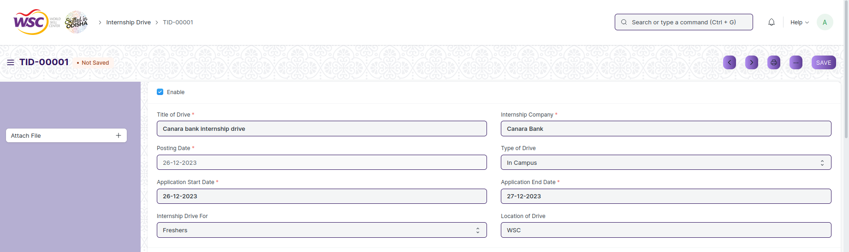

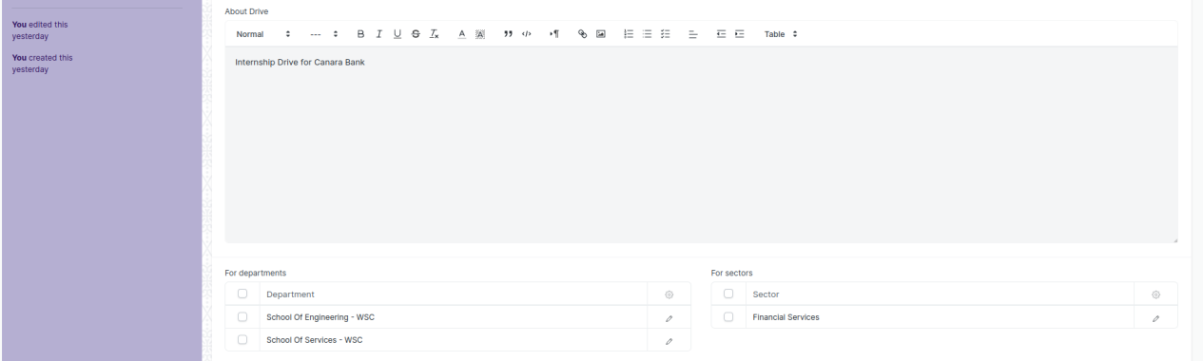

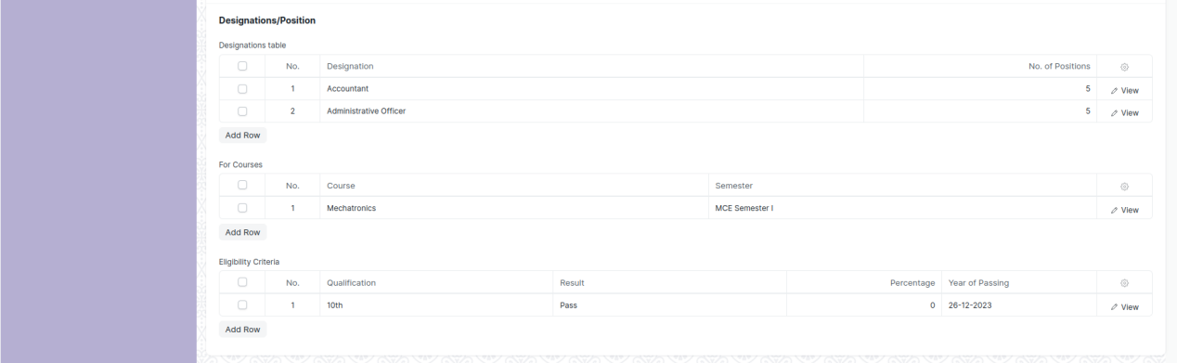

Fig 11: Internship Drive Screen

**Field List**

The following table describes the UI fields present in this screen :

|  |  |  |  |  |  |  |
| --- | --- | --- | --- | --- | --- | --- |
| **ID** | **Field Name** | **Field Type** | **Mandatory** | **Validation/ Action** | **Remarks** | **R/N/D** |
| 1 | Enable | Checkbox |  |  |  |  |
| 2 | Title of Drive | Data | Yes |  |  |  |
| 3 | Company Name | Data |  |  |  |  |
| 4 | Posting Date | Date | Yes |  |  |  |
| 5 | Application Start Date | Date | Yes |  |  |  |
| 6 | Internship Drive For | Select |  |  |  |  |
| 7 | Internship Company | Link | Yes |  |  |  |
| 8 | Company Sector | Data |  |  |  |  |
| 9 | Type of Drive | Select |  |  |  |  |
| 10 | Application End Date | Date | Yes |  |  |  |
| 11 | Location of Drive | Link |  |  |  |  |
| 12 | About Drive | Text Editor |  |  |  |  |
| 13 | Current Date | Date |  |  |  |  |
| **For departments** | | | | | | |
| 14 | Department | Link |  | Department |  |  |
| **For sectors** | | | | | | |
| 15 | Sector | Link |  | Sector |  |  |
| **Designations table** | | | | | | |
| 16 | Designation | Link |  | Designation |  |  |
| 17 | No. of Positions | Int |  |  |  |  |
| **For Courses** | | | | | | |
| 18 | Programs | Link |  | Programs |  |  |
| 19 | Semester | Link |  | Program |  |  |
| **Eligibility Criteria** | | | | | | |
| 20 | Qualification | Select |  | 10th  12th  Diploma  ITI  UG  PG |  |  |
| 21 | Result | Select |  | Pass  Fail |  |  |
| 22 | Percentage | Float |  |  |  |  |
| 23 | Year of Passing | Date |  |  |  |  |

**User: Roles & Permission**

The following table describes the users and their roles and permissions for the screens :

|  |  |  |  |  |  |  |  |  |
| --- | --- | --- | --- | --- | --- | --- | --- | --- |
| **ID** | **Role** | **Read** | **Write** | **Create** | **Delete** | **Submit** | **Cancel** | **Amend** |
| 1 | Training and Placement Administrator | Yes | Yes | Yes | NA | NA | NA | NA |
| 2 | Student | Yes | No | No | NA | NA | NA | NA |
| 3 | Employee | Yes | No | No | NA | NA | NA | NA |

### Internship Application

**General Description**

The following table describes overall information about this screen:

|  |  |  |
| --- | --- | --- |
| **Description** | | This screen is used for creating applications which will be used by the students for applying to an internship drive. |
| **Navigation** | Home > Training and Placement > Internships > Internship Application | |
| **Pre-requisites** | NA | |
| **Existing Screen Name** | No Change | |
| **New Screen Name** | Internship Application | |

**Screenshot**

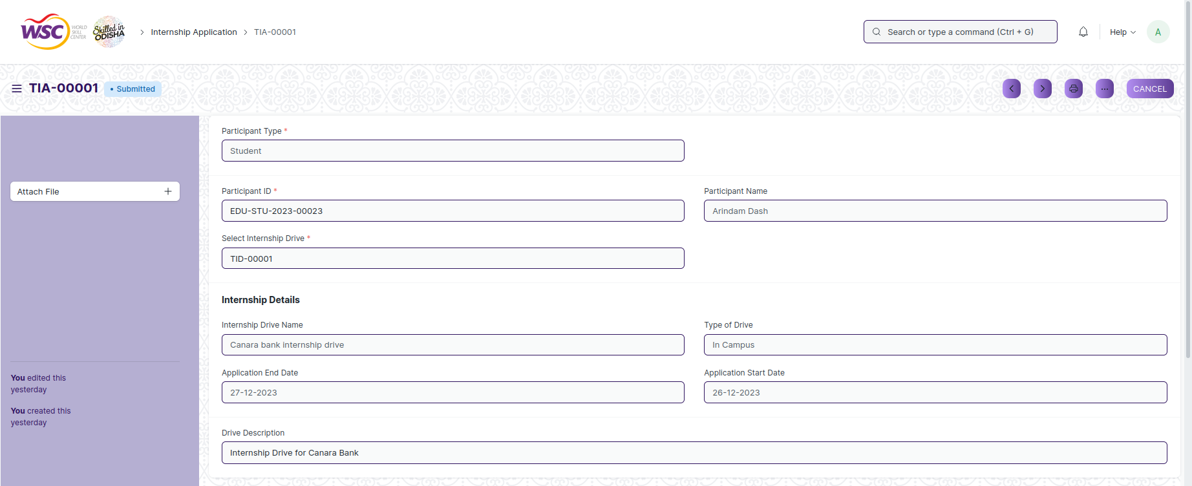

Fig 12: Internship Application Screen

**Field List**

The following table describes the UI fields present in this screen :

|  |  |  |  |  |  |  |
| --- | --- | --- | --- | --- | --- | --- |
| **ID** | **Field Name** | **Field Type** | **Mandatory** | **Validation/ Action** | **Remarks** | **R/N/D** |
| 1 | Participant Type | Select | Yes | Student  Employee |  |  |
| 2 | Participant ID | Dynamic Link | Yes | participant_type |  |  |
| 3 | Select Internship Drive | Link | Yes | Internship Drive |  |  |
| 4 | Participant Name | Data |  |  |  |  |
| 5 | Internship Name | Data |  |  |  |  |
| 6 | Company Name | Data |  |  |  |  |
| 7 | Internship Drive Name | Data |  |  |  |  |
| 8 | Application End Date | Date |  |  |  |  |
| 9 | Company Sector | Data |  |  |  |  |
| 10 | Type of Drive | Data |  |  |  |  |
| 11 | Application Start Date | Date |  |  |  |  |
| 12 | Drive Description | Text Editor |  |  |  |  |

**User: Roles & Permission**

The following table describes the users and their roles and permissions for the screens :

|  |  |  |  |  |  |  |  |  |
| --- | --- | --- | --- | --- | --- | --- | --- | --- |
| **ID** | **Role** | **Read** | **Write** | **Create** | **Delete** | **Submit** | **Cancel** | **Amend** |
| 1 | Training and Placement Administrator | Yes | Yes | Yes | NA | Yes | Yes | Yes |
| 2 | Student | Yes | Yes | Yes | NA | Yes | Yes | Yes |
| 3 | Employee | Yes | Yes | Yes | NA | Yes | Yes | Yes |

### Internship Participant Selection

**General Description**

The following table describes overall information about this screen:

|  |  |  |
| --- | --- | --- |
| **Description** | | This screen is used to select and create the final list of students who will be selected for an internship. |
| **Navigation** | Home > Training and Placement > Internships > Internship Participant Selection | |
| **Pre-requisites** | NA | |
| **Existing Screen Name** | No Change | |
| **New Screen Name** | Internship Participant Selection | |

**Screenshot**

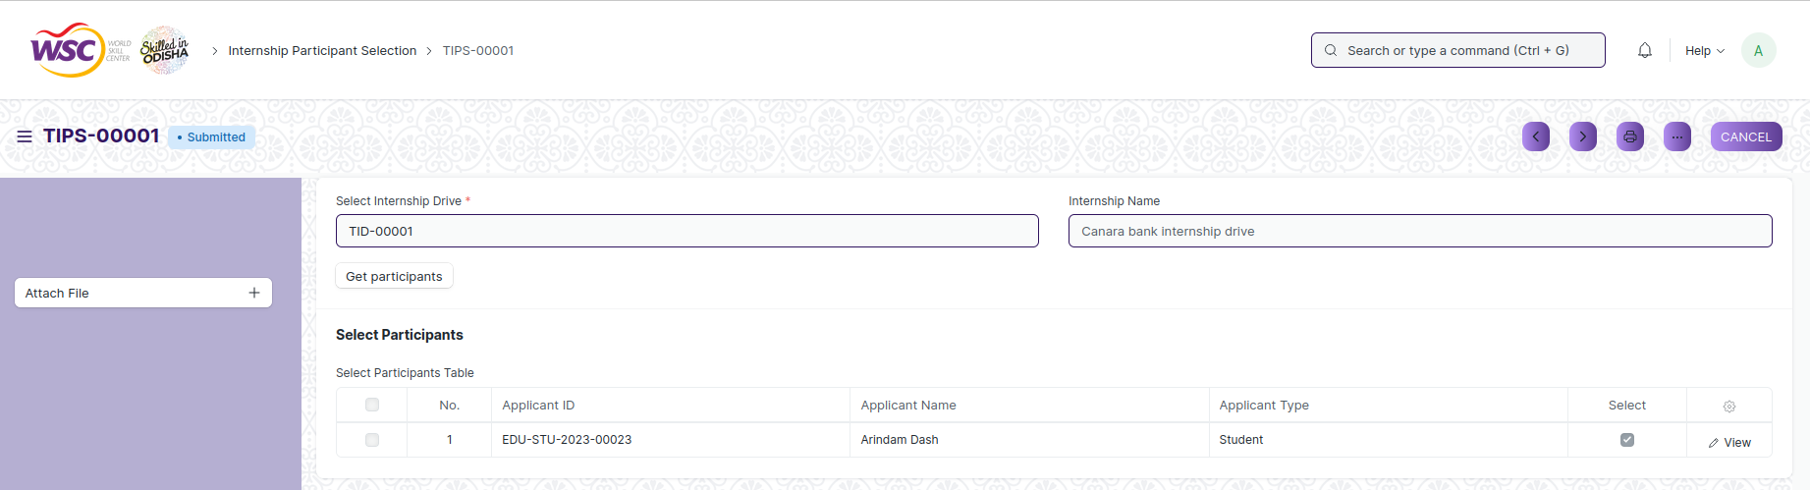

Fig 13: Internship Participant Selection Screen

**Field List**

The following table describes the UI fields present in this screen :

|  |  |  |  |  |  |  |
| --- | --- | --- | --- | --- | --- | --- |
| **ID** | **Field Name** | **Field Type** | **Mandatory** | **Validation/ Action** | **Remarks** | **R/N/D** |
| 1 | Select Internship Drive | Link | Yes | Internship Drive |  |  |
| 2 | Get Participants | Button |  |  |  |  |
| 3 | Internship Name | Data |  |  |  |  |
| **Select Participants Table** | | | | | | |
| 4 | Applicant ID | Data |  |  |  |  |
| 5 | Applicant Name | Data |  |  |  |  |
| 6 | Applicant Type | Data |  |  |  |  |
| 7 | Select | Checkbox |  |  |  |  |

**User: Roles & Permission**

The following table describes the users and their roles and permissions for the screens :

|  |  |  |  |  |  |  |  |  |
| --- | --- | --- | --- | --- | --- | --- | --- | --- |
| **ID** | **Role** | **Read** | **Write** | **Create** | **Delete** | **Submit** | **Cancel** | **Amend** |
| 1 | Training and Placement Administrator | Yes | Yes | Yes | NA | Yes | Yes | Yes |

### Internship Final List Declaration

**General Description**

The following table describes overall information about this screen:

|  |  |  |
| --- | --- | --- |
| **Description** | | This screen is used to declare the list of applicants who have been chosen for an internship drive. |
| **Navigation** | Home > Training and Placement > Internships > Internship Final List Declaration | |
| **Pre-requisites** | NA | |
| **Existing Screen Name** | No Change | |
| **New Screen Name** | Internship Final List Declaration | |

**Screenshot**

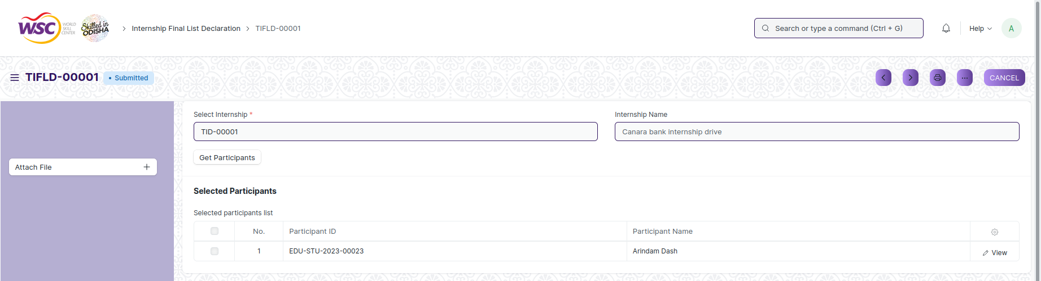

Fig 14: Internship Final List Declaration Screen

**Field List**

The following table describes the UI fields present in this screen :

|  |  |  |  |  |  |  |
| --- | --- | --- | --- | --- | --- | --- |
| **ID** | **Field Name** | **Field Type** | **Mandatory** | **Validation/ Action** | **Remarks** | **R/N/D** |
| 1 | Select Internship | Link | Yes | Internship Drive |  |  |
| 2 | Get Participants | Button |  |  |  |  |
| 3 | Internship Name | Data |  |  |  |  |
| **Selected participants list** | | | | | | |
| 4 | Participant ID | Data |  |  |  |  |
| 5 | Participant Name | Data |  |  |  |  |

**User: Roles & Permission**

The following table describes the users and their roles and permissions for the screens :

|  |  |  |  |  |  |  |  |  |
| --- | --- | --- | --- | --- | --- | --- | --- | --- |
| **ID** | **Role** | **Read** | **Write** | **Create** | **Delete** | **Submit** | **Cancel** | **Amend** |
| 1 | Training and Placement Administrator | Yes | Yes | Yes | NA | Yes | Yes | Yes |
| 2 | Student | Yes | No | No | NA | NA | NA | NA |
| 3 | Employee | Yes | No | No | NA | NA | NA | NA |

### Internship Completion Status

**General Description**

The following table describes overall information about this screen:

|  |  |  |
| --- | --- | --- |
| **Description** | | This screen is used for recording whether a student has completed an Internship they participated in or not. |
| **Navigation** | Home > Training and Placement > Internships > Internship Completion Status | |
| **Pre-requisites** | NA | |
| **Existing Screen Name** | No Change | |
| **New Screen Name** | Internship Completion Status | |

**Screenshot**

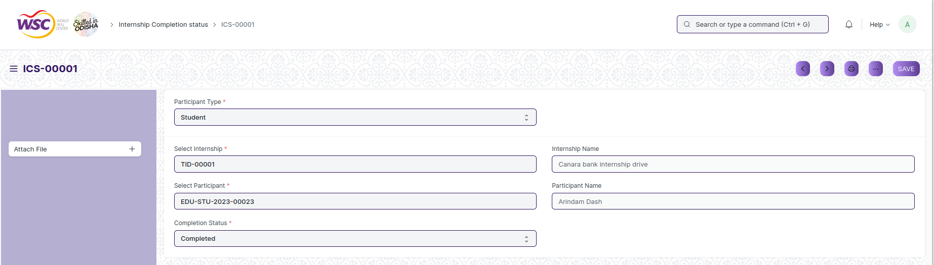

Fig 15: Internship Completion Status Screen

**Field List**

The following table describes the UI fields present in this screen :

|  |  |  |  |  |  |  |
| --- | --- | --- | --- | --- | --- | --- |
| **ID** | **Field Name** | **Field Type** | **Mandatory** | **Validation/ Action** | **Remarks** | **R/N/D** |
| 1 | Participant Type | Select | Yes | Student  Employee |  |  |
| 2 | Select Internship | Link | Yes | Internship Drive |  |  |
| 3 | Select Participant | Dynamic Link | Yes | Participant_type |  |  |
| 4 | Completion Status | Select | Yes | Completed  Not completed |  |  |
| 5 | Internship Name | Data |  |  |  |  |
| 6 | Participant Name | Data |  |  |  |  |

**User: Roles & Permission**

The following table describes the users and their roles and permissions for the screens :

|  |  |  |  |  |  |  |  |  |
| --- | --- | --- | --- | --- | --- | --- | --- | --- |
| **ID** | **Role** | **Read** | **Write** | **Create** | **Delete** | **Submit** | **Cancel** | **Amend** |
| 1 | Training and Placement Administrator | Yes | Yes | Yes | NA | NA | NA | NA |

### TnP Program

**General Description**

The following table describes overall information about this screen:

|  |  |  |
| --- | --- | --- |
| **Description** | | A TnP Program is an event that comprises of one or multiple TnP Event. |
| **Navigation** | Home > Training and Placement > Training Events > TnP Program | |
| **Pre-requisites** | NA | |
| **Existing Screen Name** | No Change | |
| **New Screen Name** | TnP Program | |

**Screenshot**

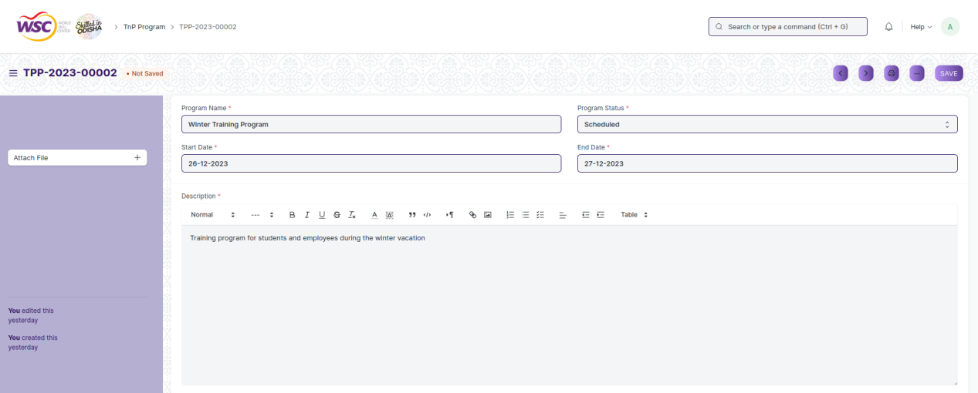



Fig 16: TnP Program Screen

**Field List**

The following table describes the UI fields present in this screen :

|  |  |  |  |  |  |  |
| --- | --- | --- | --- | --- | --- | --- |
| **ID** | **Field Name** | **Field Type** | **Mandatory** | **Validation/ Action** | **Remarks** | **R/N/D** |
| 1 | Program Name | Data | Yes |  |  |  |
| 2 | Start Date | Date | Yes |  |  |  |
| 3 | Current Date | Date |  |  |  |  |
| 4 | Program Status | Select | Yes |  |  |  |
| 5 | End Date | Date | Yes |  |  |  |
| 6 | Description | Text Editor | Yes |  |  |  |
| **Chief coordinators list** | | | | | | |
| 7 | Coordinator ID | Link | Yes | Employee |  |  |
| 8 | Coordinator Name | Data | Yes |  |  |  |
| 9 | Role | Data | Yes |  |  |  |
| 10 | Contact Number | Data | Yes |  |  |  |
| 11 | Email | Data | Yes | Email |  |  |

**User: Roles & Permission**

The following table describes the users and their roles and permissions for the screens :

|  |  |  |  |  |  |  |  |  |
| --- | --- | --- | --- | --- | --- | --- | --- | --- |
| **ID** | **Role** | **Read** | **Write** | **Create** | **Delete** | **Submit** | **Cancel** | **Amend** |
| 1 | Training and Placement Administrator | Yes | Yes | Yes | NA | NA | NA | NA |
| 2 | Student | Yes | No | No | NA | NA | NA | NA |
| 3 | Employee | Yes | No | No | NA | NA | NA | NA |

### TnP Event

**General Description**

The following table describes overall information about this screen:

|  |  |  |
| --- | --- | --- |
| **Description** | | A TnP event is an event which can be an individual part of a TnP Program and be scheduled within the program or can be a stand alone event that can be scheduled on its own time. |
| **Navigation** | Home > Training and Placement > Training Events > TnP Event | |
| **Pre-requisites** | NA | |
| **Existing Screen Name** | No Change | |
| **New Screen Name** | TnP Event | |

**Screenshot**

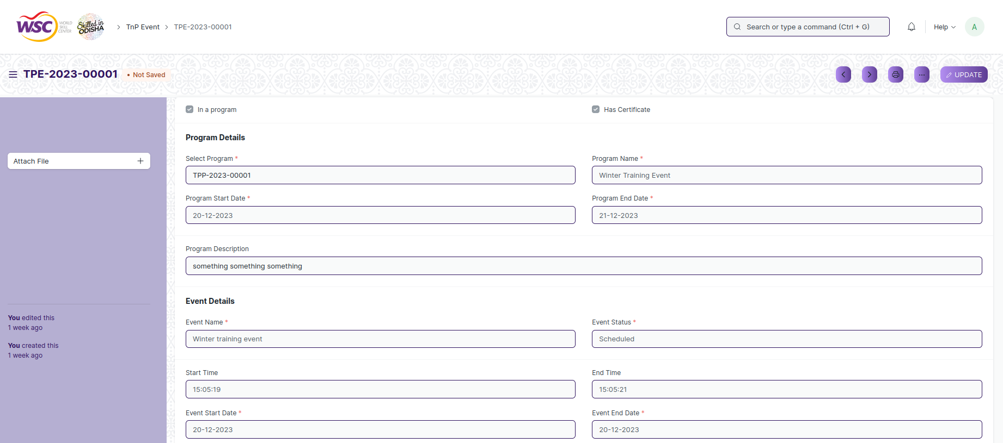



Fig 17: TnP Event Screen

**Field List**

The following table describes the UI fields present in this screen :

|  |  |  |  |  |  |  |
| --- | --- | --- | --- | --- | --- | --- |
| **ID** | **Field Name** | **Field Type** | **Mandatory** | **Validation/ Action** | **Remarks** | **R/N/D** |
| 1 | In a program | Checkbox |  |  |  |  |
| 2 | Has Certificate | Checkbox |  |  |  |  |
| 3 | Select Program | Link |  | TnP Program |  |  |
| 4 | Program Start Date | Date |  |  |  |  |
| 5 | Program Name | Data |  |  |  |  |
| 6 | Program End Date | Date |  |  |  |  |
| 7 | Program Description | Text Editor |  |  |  |  |
| 8 | Event Name | Data | Yes |  |  |  |
| 9 | Event Status | Select | Yes |  |  |  |
| 10 | Start Time | Time |  |  |  |  |
| 11 | Event Start Date | Date | Yes |  |  |  |
| 12 | Event Location | Link | Yes | Location |  |  |
| 13 | End Time | Time |  |  |  |  |
| 14 | Event End Date | Date | Yes |  |  |  |
| 15 | Event Type | Select | Yes | Seminar  Conference |  |  |
| 16 | Current Date | Date |  |  |  |  |
| **Coordinators List** | | | | | | |
| 17 | Coordinator ID | Link | Yes | Employee |  |  |
| 18 | Coordinator Name | Data | Yes |  |  |  |
| 19 | Role | Data | Yes |  |  |  |
| 20 | Contact Number | Data | Yes |  |  |  |
| 21 | Email | Data | Yes | Email |  |  |

**User: Roles & Permission**

The following table describes the users and their roles and permissions for the screens :

|  |  |  |  |  |  |  |  |  |
| --- | --- | --- | --- | --- | --- | --- | --- | --- |
| **ID** | **Role** | **Read** | **Write** | **Create** | **Delete** | **Submit** | **Cancel** | **Amend** |
| 1 | Training and Placement Administrator | Yes | Yes | Yes | NA | Yes | Yes | Yes |
| 2 | Student | Yes | No | No | NA | NA | NA | NA |
| 3 | Employee | Yes | No | No | NA | NA | NA | NA |

### Participant Registration

**General Description**

The following table describes overall information about this screen:

|  |  |  |
| --- | --- | --- |
| **Description** | | Participant Registration is a form that will be provided to individuals to register for an event. It maintains the records of all the Registrations made for TnP events using the system. |
| **Navigation** | Home > Training and Placement > Training Events > Participant Registration | |
| **Pre-requisites** | NA | |
| **Existing Screen Name** | No Change | |
| **New Screen Name** | Participant Registration | |

**Screenshot**

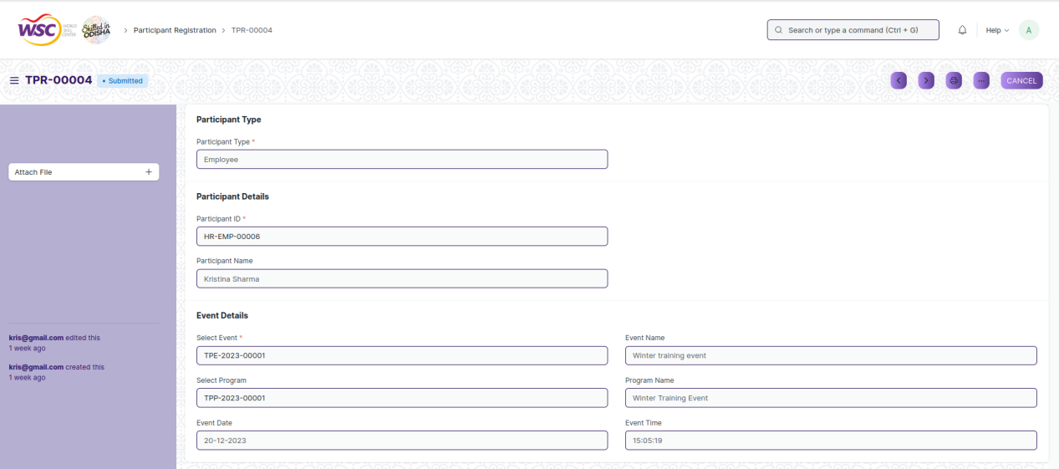

Fig 18: Participant Registration Screen

**Field List**

The following table describes the UI fields present in this screen :

|  |  |  |  |  |  |  |
| --- | --- | --- | --- | --- | --- | --- |
| **ID** | **Field Name** | **Field Type** | **Mandatory** | **Validation/ Action** | **Remarks** | **R/N/D** |
| 1 | Participant Type | Select | Yes | Student  Employee |  |  |
| 2 | Participant ID | Dynamic Link | Yes | Participant_type |  |  |
| 3 | Participant Name | Data |  |  |  |  |
| 4 | Select Event | Link | Yes | TnP Event |  |  |
| 5 | Select Program | Link |  | TnP Program |  |  |
| 6 | Event Date | Date |  |  |  |  |
| 7 | Event Name | Data |  |  |  |  |
| 8 | Program Name | Data |  |  |  |  |
| 9 | Event Time | Data |  |  |  |  |

**User: Roles & Permission**

The following table describes the users and their roles and permissions for the screens :

|  |  |  |  |  |  |  |  |  |
| --- | --- | --- | --- | --- | --- | --- | --- | --- |
| **ID** | **Role** | **Read** | **Write** | **Create** | **Delete** | **Submit** | **Cancel** | **Amend** |
| 1 | Training and Placement Administrator | Yes | Yes | Yes | NA | Yes | Yes | Yes |
| 2 | Student | Yes | Yes | Yes | NA | Yes | Yes | Yes |
| 3 | Employee | Yes | Yes | Yes | NA | Yes | Yes | Yes |

### Participant Attendance

**General Description**

The following table describes overall information about this screen:

|  |  |  |
| --- | --- | --- |
| **Description** | | This screen is used to mark and maintain records of attendance for participants during a TnP event. |
| **Navigation** | Home > Training and Placement > Training Events > Participant Attendance | |
| **Pre-requisites** | NA | |
| **Existing Screen Name** | No Change | |
| **New Screen Name** | Participant Attendance | |

**Screenshot**

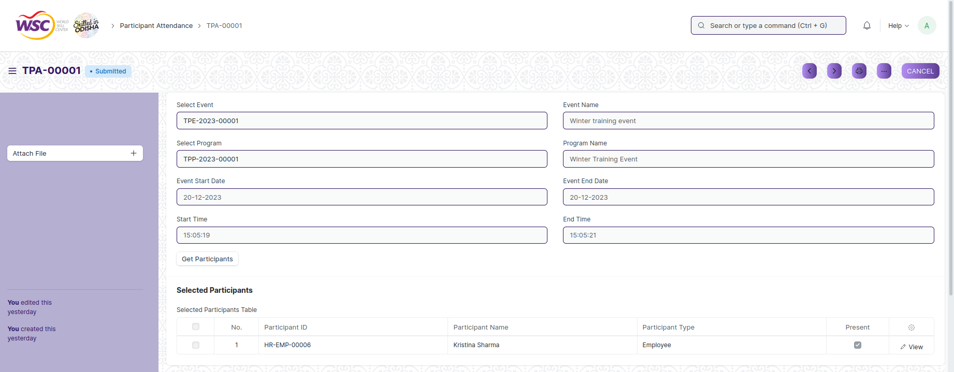

Fig 19: Participant Attendance Screen

**Field List**

The following table describes the UI fields present in this screen :

|  |  |  |  |  |  |  |
| --- | --- | --- | --- | --- | --- | --- |
| **ID** | **Field Name** | **Field Type** | **Mandatory** | **Validation/ Action** | **Remarks** | **R/N/D** |
| 1 | Select Event | Link |  | TnP Event |  |  |
| 2 | Select Program | Link |  | TnP Program |  |  |
| 3 | Event Start Date | Date |  |  |  |  |
| 4 | Start Time | Time |  |  |  |  |
| 5 | Get Participants | Button |  |  |  |  |
| 6 | Event Name | Data |  |  |  |  |
| 7 | Program Name | Data |  |  |  |  |
| 8 | Event End Date | Date |  |  |  |  |
| 9 | End Time | Time |  |  |  |  |
| **Selected Participants Table** | | | | | | |
| 10 | Participant ID | Data |  |  |  |  |
| 11 | Participant Name | Data |  |  |  |  |
| 12 | Participant Type | Data |  |  |  |  |
| 13 | Present | Checkbox |  |  |  |  |

**User: Roles & Permission**

The following table describes the users and their roles and permissions for the screens :

|  |  |  |  |  |  |  |  |  |
| --- | --- | --- | --- | --- | --- | --- | --- | --- |
| **ID** | **Role** | **Read** | **Write** | **Create** | **Delete** | **Submit** | **Cancel** | **Amend** |
| 1 | Training and Placement Administrator | Yes | Yes | Yes | NA | Yes | Yes | Yes |
| 2 | Student | Yes | NA | NA | NA | NA | NA | NA |
| 3 | Employee | Yes | NA | NA | NA | NA | NA | NA |

### Event Feedback

**General Description**

The following table describes overall information about this screen:

|  |  |  |
| --- | --- | --- |
| **Description** | | This screen is provided to the participants for recording their feedback regarding a TnP Event. |
| **Navigation** | Home > Training and Placement > Training Events > Event Feedback | |
| **Pre-requisites** | NA | |
| **Existing Screen Name** | No Change | |
| **New Screen Name** | Event Feedback | |

**Screenshot**

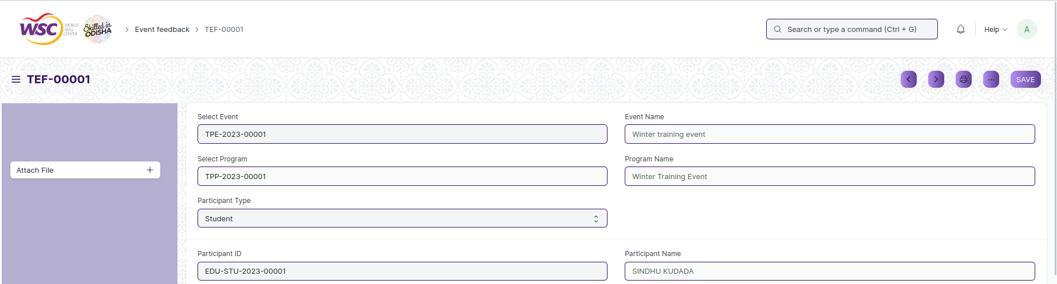

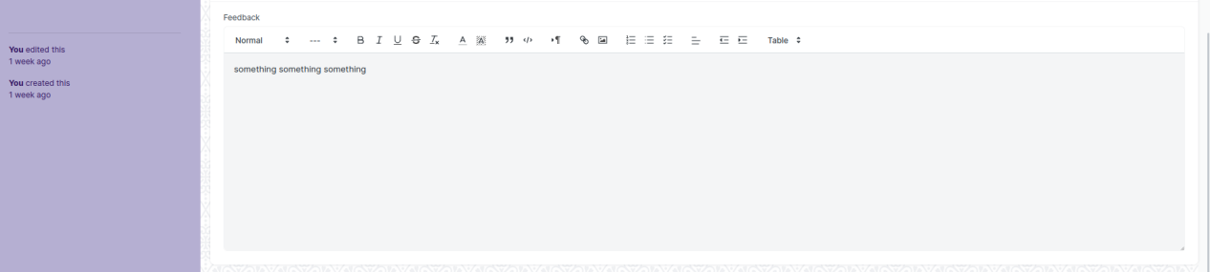

Fig 20: Event Feedback Screen

**Field List**

The following table describes the UI fields present in this screen :

|  |  |  |  |  |  |  |
| --- | --- | --- | --- | --- | --- | --- |
| **ID** | **Field Name** | **Field Type** | **Mandatory** | **Validation/ Action** | **Remarks** | **R/N/D** |
| 1 | Select Event | Link |  | TnP Event |  |  |
| 2 | Select Program | Link |  | TnP Program |  |  |
| 3 | Participant Type | Select |  | Student  Employee |  |  |
| 4 | Event Name | Data |  |  |  |  |
| 5 | Program Name | Data |  |  |  |  |
| 6 | Participant ID | Dynamic Link |  | participant_type |  |  |
| 7 | Participant Name | Data |  |  |  |  |
| 8 | Feedback | Text Editor |  |  |  |  |

**User: Roles & Permission**

The following table describes the users and their roles and permissions for the screens :

|  |  |  |  |  |  |  |  |  |
| --- | --- | --- | --- | --- | --- | --- | --- | --- |
| **ID** | **Role** | **Read** | **Write** | **Create** | **Delete** | **Submit** | **Cancel** | **Amend** |
| 1 | Training and Placement Administrator | Yes | Yes | Yes | NA | NA | NA | NA |
| 2 | Student | Yes | Yes | Yes | NA | NA | NA | NA |
| 3 | Employee | Yes | Yes | Yes | NA | NA | NA | NA |

### Generate Certificate Tool

**General Description**

The following table describes overall information about this screen:

|  |  |  |
| --- | --- | --- |
| **Description** | | This screen is used by the user to generate certificates in bulk for the eligible participants of an event. |
| **Navigation** | Home > Training and Placement > Training Events > Generate Certificate Tool | |
| **Pre-requisites** | NA | |
| **Existing Screen Name** | No Change | |
| **New Screen Name** | Generate Certificate Tool | |

**Screenshot**

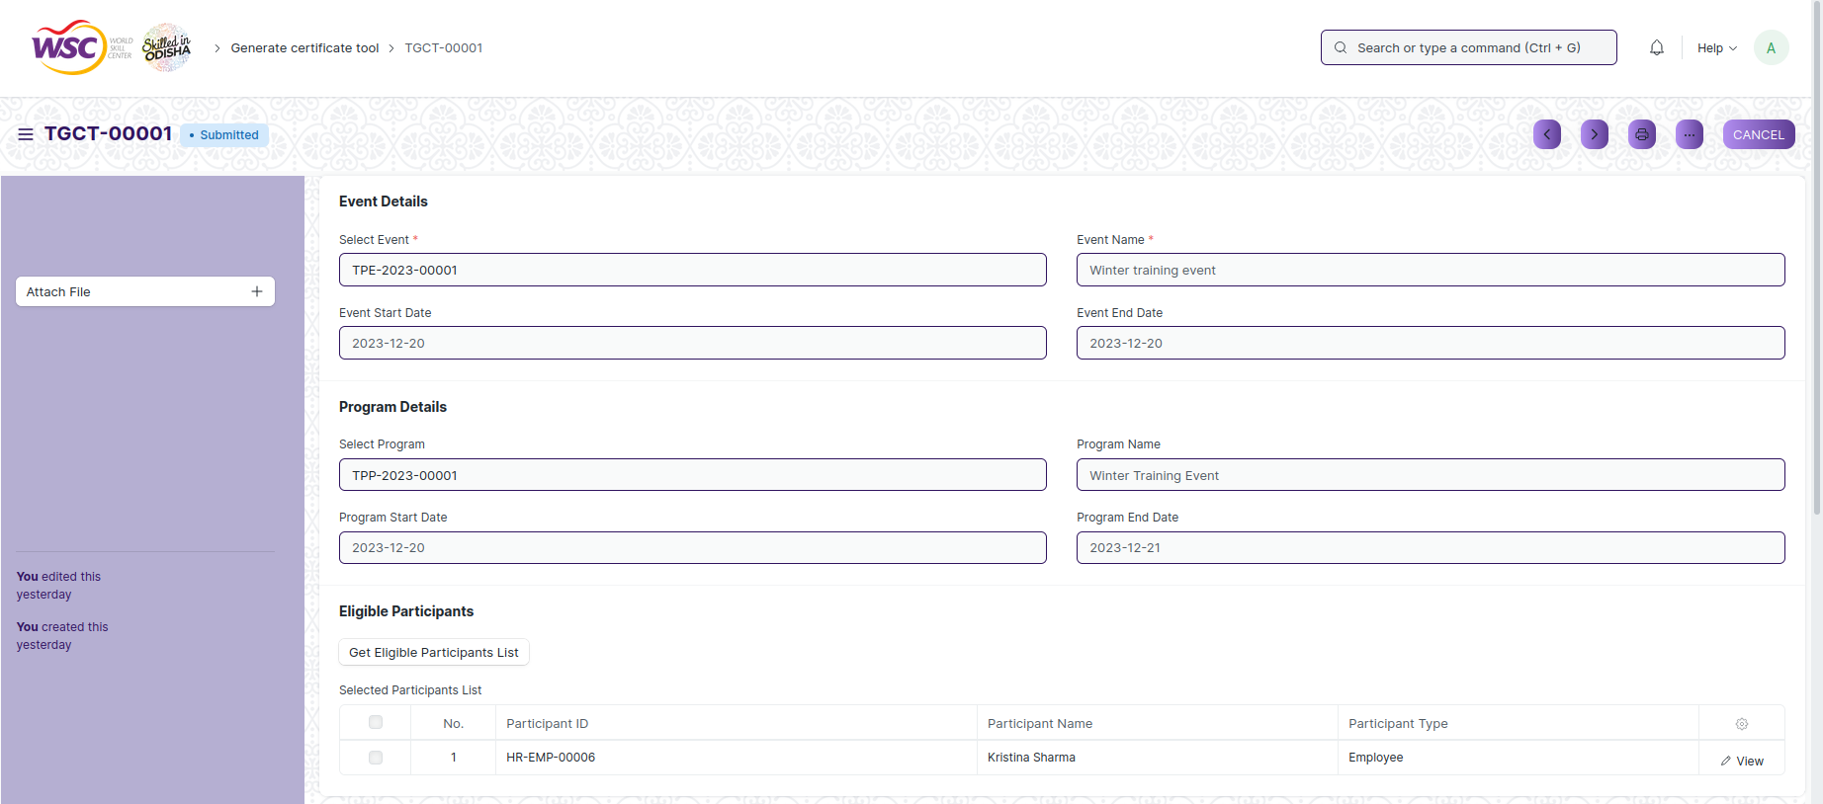

Fig 21: Generate Certificate Tool Screen

**Field List**

The following table describes the UI fields present in this screen :

|  |  |  |  |  |  |  |
| --- | --- | --- | --- | --- | --- | --- |
| **ID** | **Field Name** | **Field Type** | **Mandatory** | **Validation/ Action** | **Remarks** | **R/N/D** |
| 1 | Select Event | Link | Yes | TnP Event |  |  |
| 2 | Event Start Date | Data |  |  |  |  |
| 3 | Event Name | Data | Yes |  |  |  |
| 4 | Event End Date | Data |  |  |  |  |
| 5 | Select Program | Link |  | TnP Program |  |  |
| 6 | Program Start Date | Data |  |  |  |  |
| 7 | Program Name | Data |  |  |  |  |
| 8 | Program End Date | Data |  |  |  |  |
| 9 | Get Eligible Participants List | Button |  |  |  |  |
| **Get Eligible Participants Table** | | | | | | |
| 10 | Participant ID | Data |  |  |  |  |
| 11 | Participant Name | Data |  |  |  |  |
| 12 | Participant Type | Data |  |  |  |  |

**User: Roles & Permission**

The following table describes the users and their roles and permissions for the screens :

|  |  |  |  |  |  |  |  |  |
| --- | --- | --- | --- | --- | --- | --- | --- | --- |
| **ID** | **Role** | **Read** | **Write** | **Create** | **Delete** | **Submit** | **Cancel** | **Amend** |
| 1 | Training and Placement Administrator | Yes | Yes | Yes | NA | Yes | Yes | Yes |

### Generate Certificate

**General Description**

The following table describes overall information about this screen:

|  |  |  |
| --- | --- | --- |
| **Description** | | The screen is used to generate certificate for participants of an event who are eligible for it. |
| **Navigation** | Home > Training and Placement > Training Events > Generate Certificate | |
| **Pre-requisites** | NA | |
| **Existing Screen Name** | No Change | |
| **New Screen Name** | Generate Certificate | |

**Screenshot**

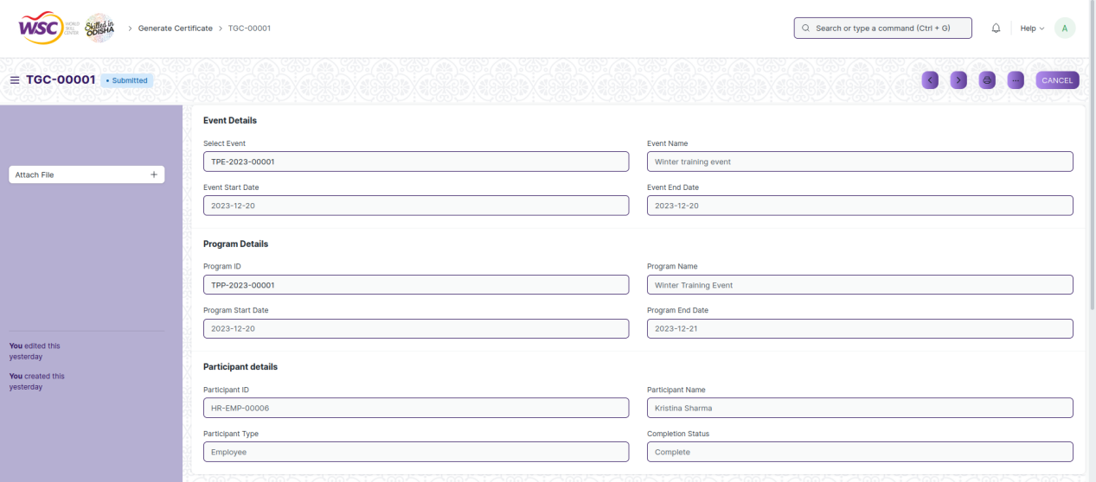

Fig 22: Generate Certificate Screen

**Field List**

The following table describes the UI fields present in this screen :

|  |  |  |  |  |  |  |
| --- | --- | --- | --- | --- | --- | --- |
| **ID** | **Field Name** | **Field Type** | **Mandatory** | **Validation/ Action** | **Remarks** | **R/N/D** |
| 1 | Select Event | Link |  | TnP Event |  |  |
| 2 | Event Start Date | Data |  |  |  |  |
| 3 | Event Name | Data |  |  |  |  |
| 4 | Event End Date | Data |  |  |  |  |
| 5 | Program ID | Link |  | TnP Program |  |  |
| 6 | Program Start Date | Data |  |  |  |  |
| 7 | Program Name | Data |  |  |  |  |
| 8 | Program End Date | Data |  |  |  |  |
| 9 | Participant ID | Select |  |  |  |  |
| 10 | Participant Type | Data |  |  |  |  |
| 11 | Participant Name | Data |  |  |  |  |
| 12 | Completion Status | Select |  | Complete  Incomplete |  |  |

**User: Roles & Permission**

The following table describes the users and their roles and permissions for the screens :

|  |  |  |  |  |  |  |  |  |
| --- | --- | --- | --- | --- | --- | --- | --- | --- |
| **ID** | **Role** | **Read** | **Write** | **Create** | **Delete** | **Submit** | **Cancel** | **Amend** |
| 1 | Training and Placement Administrator | Yes | Yes | Yes | NA | Yes | Yes | Yes |

### Entrepreneurship

**General Description**

The following table describes overall information about this screen:

|  |  |  |
| --- | --- | --- |
| **Description** | | This screen is used to create and maintain records of companies that have been started by WSC students. |
| **Navigation** | Home > Training and Placement > Masters > Entrepreneurship | |
| **Pre-requisites** | NA | |
| **Existing Screen Name** | No Change | |
| **New Screen Name** | Entrepreneurship | |

**Screenshot**

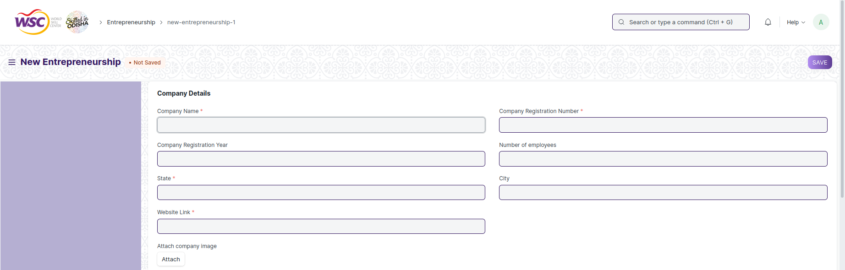

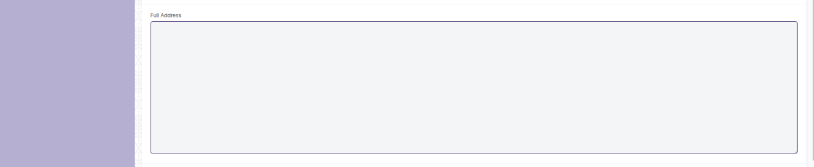

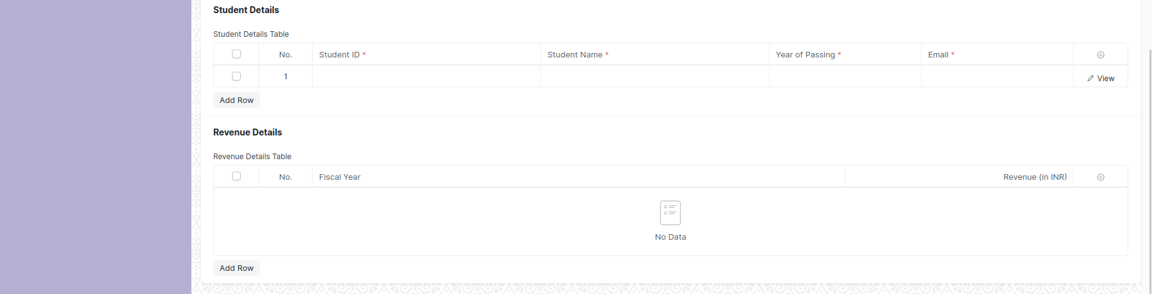

Fig 23: Entrepreneurship Screen

**Field List**

The following table describes the UI fields present in this screen :

|  |  |  |  |  |  |  |
| --- | --- | --- | --- | --- | --- | --- |
| **ID** | **Field Name** | **Field Type** | **Mandatory** | **Validation/ Action** | **Remarks** | **R/N/D** |
| 1 | Company Name | Data | Yes |  |  |  |
| 2 | Company Registration Year | Link |  | Year |  |  |
| 3 | State | Link | Yes | State |  |  |
| 4 | Website Link | Data | Yes |  |  |  |
| 5 | Attach company image | Attach Image |  |  |  |  |
| 6 | Company Registration Number | Data | Yes |  |  |  |
| 7 | Number of Employees | Data |  |  |  |  |
| 8 | City | Data |  |  |  |  |
| 9 | Full Address | Long Text |  |  |  |  |
| **Student Details Table** | | | | | | |
| 10 | Student ID | Link | Yes | Student |  |  |
| 11 | Student Name | Data | Yes |  |  |  |
| 12 | Year of Passing | Link | Yes | Year |  |  |
| 13 | Email | Data | Yes |  |  |  |
| **Revenue Details Table** | | | | | | |
| 14 | Fiscal Year | Link |  | Fiscal Year |  |  |
| 15 | Revenue (in INR) | Currency |  |  |  |  |

**User: Roles & Permission**

The following table describes the users and their roles and permissions for the screens :

|  |  |  |  |  |  |  |  |  |
| --- | --- | --- | --- | --- | --- | --- | --- | --- |
| **ID** | **Role** | **Read** | **Write** | **Create** | **Delete** | **Submit** | **Cancel** | **Amend** |
| 1 | Training and Placement Administrator | Yes | Yes | Yes | NA | NA | NA | NA |

### Sector

**General Description**

The following table describes overall information about this screen:

|  |  |  |
| --- | --- | --- |
| **Description** | | This screen is to be used for creating records fo sectors in which a company may work in. |
| **Navigation** | Home > Training and Placement > Masters > Sector | |
| **Pre-requisites** | NA | |
| **Existing Screen Name** | No Change | |
| **New Screen Name** | Sector | |

**Screenshot**

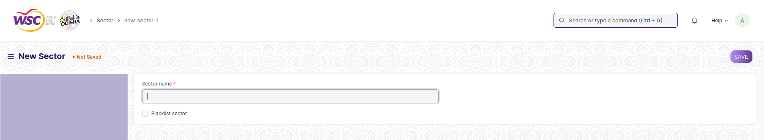

Fig 24: Sector Screen

**Field List**

The following table describes the UI fields present in this screen :

|  |  |  |  |  |  |  |
| --- | --- | --- | --- | --- | --- | --- |
| **ID** | **Field Name** | **Field Type** | **Mandatory** | **Validation/ Action** | **Remarks** | **R/N/D** |
| 1 | Sector name | Data | Yes |  |  |  |
| 2 | Blacklist Sector | Checkbox |  |  |  |  |

**User: Roles & Permission**

The following table describes the users and their roles and permissions for the screens :

|  |  |  |  |  |  |  |  |  |
| --- | --- | --- | --- | --- | --- | --- | --- | --- |
| **ID** | **Role** | **Read** | **Write** | **Create** | **Delete** | **Submit** | **Cancel** | **Amend** |
| 1 | Training and Placement Administrator | Yes | Yes | Yes | NA | NA | NA | NA |

### Resume

**General Description**

The following table describes overall information about this screen:

|  |  |  |
| --- | --- | --- |
| **Description** | | This screen is used by the student to create and manage their resumes in the system. |
| **Navigation** | Home > Training and Placement > Masters > Resume | |
| **Pre-requisites** | NA | |
| **Existing Screen Name** | No Change | |
| **New Screen Name** | Resume | |

**Screenshot**

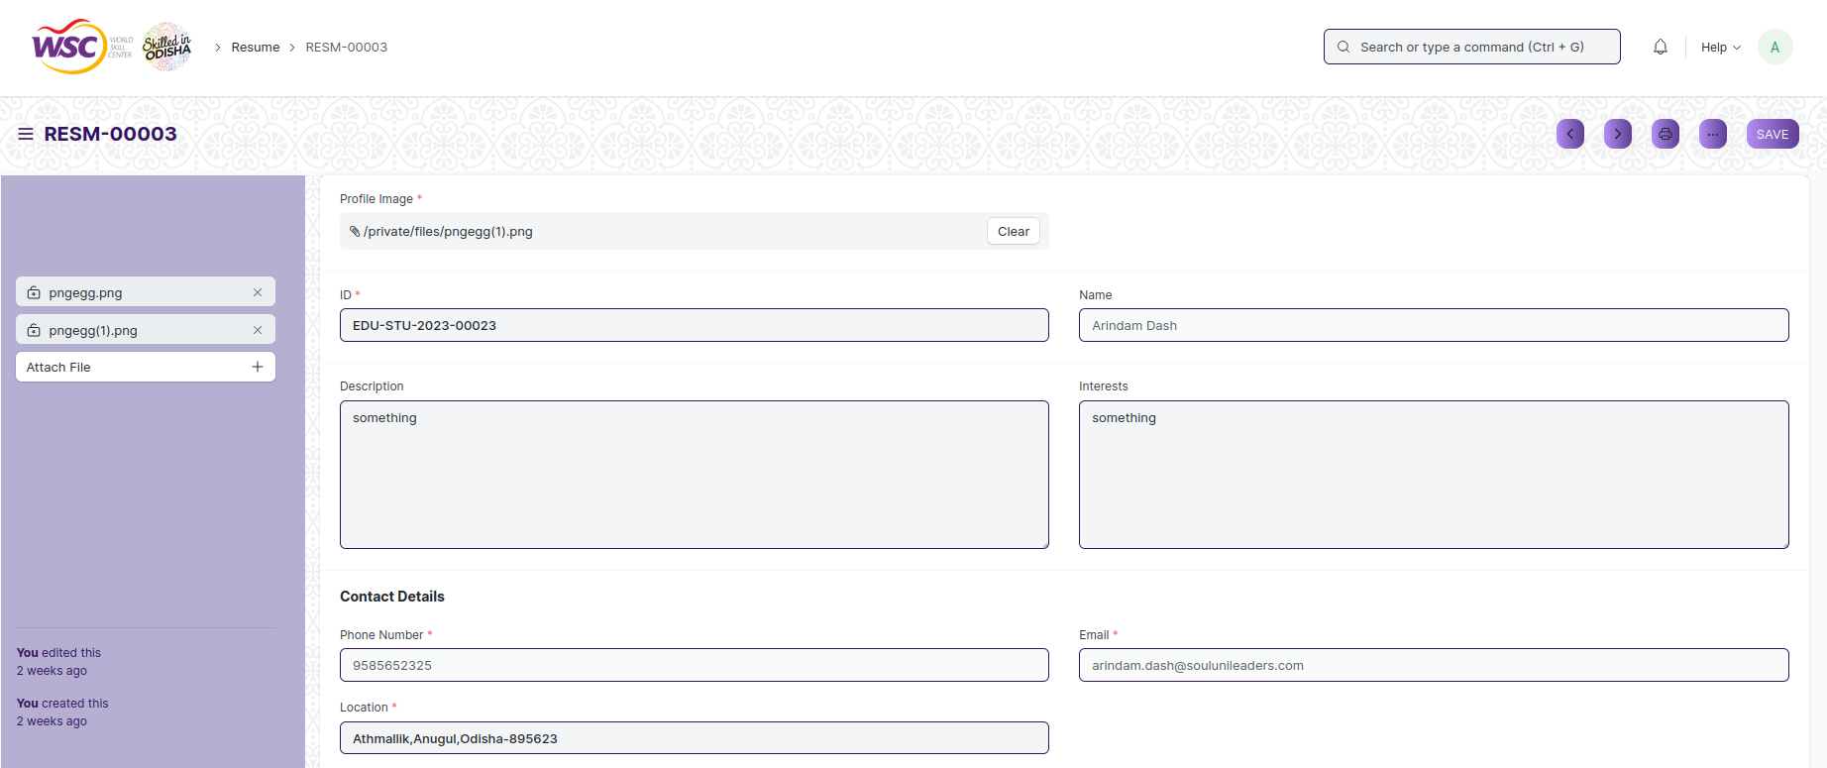

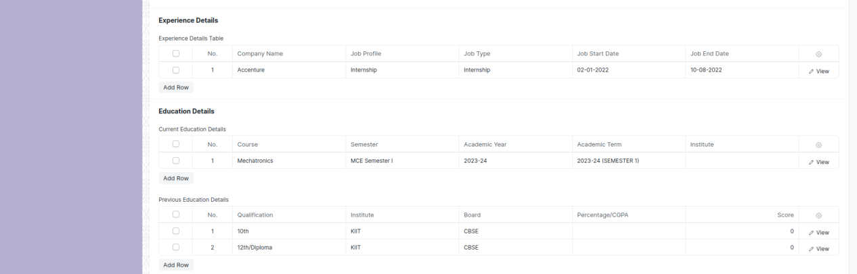

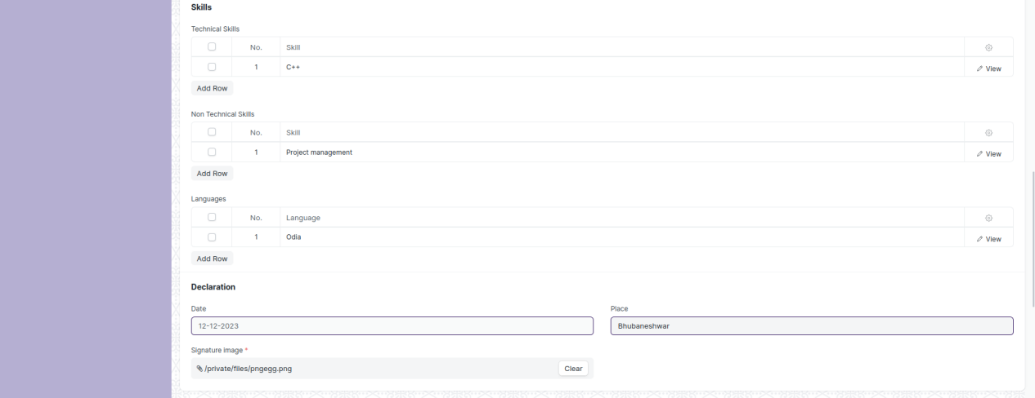

Fig 25: Resume Screen

**Field List**

The following table describes the UI fields present in this screen :

|  |  |  |  |  |  |  |
| --- | --- | --- | --- | --- | --- | --- |
| **ID** | **Field Name** | **Field Type** | **Mandatory** | **Validation/ Action** | **Remarks** | **R/N/D** |
| 1 | Profile Image | Attach Image | Yes |  |  |  |
| 2 | ID | Link | Yes | Student |  |  |
| 3 | Name | Data |  |  |  |  |
| 4 | Description | Small Text |  |  |  |  |
| 5 | Interests | Small Text |  |  |  |  |
| 6 | Phone Number | Data | Yes |  |  |  |
| 7 | Location | Data | Yes |  |  |  |
| 8 | Email | Data | Yes |  |  |  |
| 9 | Date | Date |  |  |  |  |
| 10 | Signature image | Attach | Yes |  |  |  |
| 11 | Place | Data |  |  |  |  |
| **Experience Details Table** | | | | | | |
| 12 | Company Name | Data |  |  |  |  |
| 13 | Job Profile | Data |  |  |  |  |
| 14 | Job Type | Select |  |  |  |  |
| 15 | Job Start Date | Date |  |  |  |  |
| 16 | Job End Date | Date |  |  |  |  |
| 17 | Job Location | Data |  |  |  |  |
| 18 | Work Description | Small Text |  |  |  |  |
| **Current Education Details** | | | | | | |
| 19 | Programs | Link |  | Programs |  |  |
| 20 | Semester | Link |  | Program |  |  |
| 21 | Academic Year | Link |  | Academic Year |  |  |
| 22 | Academic Term | Link |  | Academic Term |  |  |
| 23 | Institute | Data |  |  |  |  |
| 24 | Location | Data |  |  |  |  |
| **Previous Education Details** | | | | | | |
| 25 | Qualification | Link |  | Eligibility Parameters |  |  |
| 26 | Institute | Data |  |  |  |  |
| 27 | Board | Data |  |  |  |  |
| 28 | Percentage/CGPA | Select |  | Percentage  CGPA/SGPA |  |  |
| 29 | Score | Float |  |  |  |  |
| 30 | Year of Completion | Data |  |  |  |  |
| **Technical Skills** | | | | | | |
| 31 | Skill | Data |  |  |  |  |
| **Non Technical Skills** | | | | | | |
| 32 | Skill | Data |  |  |  |  |
| **Languages** | | | | | | |
| 33 | Language | Data |  |  |  |  |

**User: Roles & Permission**

The following table describes the users and their roles and permissions for the screens :

|  |  |  |  |  |  |  |  |  |
| --- | --- | --- | --- | --- | --- | --- | --- | --- |
| **ID** | **Role** | **Read** | **Write** | **Create** | **Delete** | **Submit** | **Cancel** | **Amend** |
| 1 | Training and Placement Administrator | Yes | Yes | Yes | NA | NA | NA | NA |
| 2 | Student | Yes | Yes | Yes | NA | NA | NA | NA |